Switch

A switch is a vital networking device operating within the data link layer (Layer 2) of the OSI model, crucial for local area networks (LANs). Its primary role is to connect multiple devices in a network and efficiently direct data packets based on their Media Access Control (MAC) addresses. Unlike hubs, which broadcast data to all connected devices, switches use packet switching to forward packets only to the appropriate port where the intended recipient is located. This reduces network congestion, enhances bandwidth utilization, and optimizes network performance. With multiple ports supporting connections to various devices like computers, printers, and servers, switches facilitate fast and reliable communication, playing a crucial role in modern networking infrastructure.

Functions of a switch:

1. Packet Forwarding: Switches send data packets to the right destination port based on MAC addresses, reducing unnecessary network traffic.
2. MAC Address Learning: Switches learn and remember MAC addresses of connected devices to improve packet forwarding and network performance.
3. VLAN Support: Switches allow network segmentation for better security, management, and traffic control through Virtual LANs (VLANs).
4. Quality of Service (QoS) Prioritization: Switches prioritize important traffic like VoIP or video streaming for timely delivery.
5. Port Mirroring: Switches can copy traffic from one port to another for network monitoring and troubleshooting.

Uses of a switch:

1. Local Area Networks (LANs): Switches connect devices within homes, offices, and schools, allowing seamless sharing of data and communication.
2. Internet Connectivity: Switches link devices to routers for internet access, enabling web browsing, emails, media streaming, and online services.
3. Data Center Networking: Switches connect servers and storage systems in data centers, supporting cloud computing and big data analytics.
4. Voice over IP (VoIP) and Multimedia: Switches ensure smooth connections for VoIP calls, video conferencing, and media streaming with low latency.
5. Network Security: Switches enforce security measures like port security and VLANs to control access and protect against unauthorized access and cyber threats.

Functions of a Router:

* Packet Forwarding: Routers direct data packets between networks using destination IP addresses, guided by routing tables and protocols like OSPF.
* Network Address Translation (NAT): Routers translate private IPs to public ones for internet access, enabling multiple devices to share a single public IP.
* Dynamic Routing: Routers use dynamic protocols to update routing tables automatically, adapting to network changes.
* Firewall and Security: Routers filter traffic with built-in firewalls, guarding against unauthorized access and security threats.
* VPN Support: Routers establish secure VPN connections for remote access, ensuring privacy and data encryption.

Uses of a Router:

* Internet Connectivity: Routers link LANs to the internet, granting access to online services.
* Interconnecting Networks: Routers connect LANs or WANs, enabling communication across different segments.
* Home Networking: Routers share internet connections among devices in homes, fostering internet access and resource sharing.
* Branch Office Connectivity: Routers connect remote offices to the main network, ensuring communication and resource access.
* WAN Edge Device: Routers manage traffic flow in WANs, connecting enterprise networks and optimizing connectivity across wide areas.

Routers, operating at Layer 3 of the OSI model, forward data packets between networks based on destination IP addresses. They use routing tables to determine optimal paths, connecting LANs, WANs, or the internet. Routers perform functions like network address translation (NAT), firewalling, and VPN support, crucial for secure and efficient data transmission across diverse networks.

Hub Functions:

* Broadcasting: Sends data packets to all connected devices, causing congestion.
* Signal Amplification: Boosts signals for longer cable distances.
* Collision Domain: Causes data loss when devices transmit simultaneously.
* Simple Connectivity: Offers basic, low-cost device connection.
* Basic Networking: Operates at Layer 1, lacking intelligence of switches.

Hub Uses:

* Legacy Networks: Previously used in basic Ethernet setups.
* Home Networking: Still used for simple, cost-effective home setups.
* Network Troubleshooting: Helpful for basic network monitoring.
* Education and Training: Demonstrates fundamental networking concepts.
* Temporary Expansion: Used for short-term network scaling.

A hub operates at the physical layer, connecting devices in a LAN by broadcasting data packets to all connected devices without intelligence. This creates a single collision domain, leading to network congestion. Although inexpensive, hubs are inefficient for larger networks, suitable mainly for simple setups prioritizing cost over performance, like small home networks.

Repeater Functions:

* Signal Boost: Amplifies and retransmits signals to extend network reach over long distances.
* Noise Filtering: Filters out unwanted noise or interference for better signal quality.
* Transparent Operation: Operates at Layer 1 without modifying data, simply regenerating signals.
* Easy Deployment: Plug-and-play setup for seamless integration into existing networks.
* Cost-Effective: Affordable solution for extending network connectivity compared to alternatives.

Repeater Uses:

* Network Extension: Extends wired or wireless networks for reliable connectivity over large areas.
* Ethernet LAN Extension: Connects distant network segments beyond Ethernet cable limits.
* Telecommunications: Key for long-distance transmission systems to combat signal attenuation.
* Wireless Signal Boost: Enhances coverage and strength in weak wireless areas.
* Cable TV Distribution: Ensures optimal signal quality for cable TV subscribers.

A repeater extends network range by amplifying and re-transmitting signals, compensating for signal weakening over long distances. Operating at Layer 1, it boosts signal power and maintains integrity, supporting various transmission media like copper and fiber optics. Despite simplicity, repeaters are vital for reliable communication in expansive network environments.

Modem Functions:

* Modulation/Demodulation: Converts digital to analog signals for transmission and vice versa.
* Signal Encoding: Converts digital data to analog using techniques like AM, FM, or PM.
* Carrier Wave Generation: Produces carrier waves for transmitting modulated data.
* Error Detection/Correction: Detects and corrects transmission errors for data integrity.
* Protocol Conversion: Supports various protocols for interoperability and communication.

Modem Uses:

* Internet Connectivity: Connects devices to the internet via DSL, cable, or cellular networks.
* Dial-Up Connections: Establishes temporary connections over telephone lines, often used in remote areas.
* Fax Transmission: Converts digital documents for faxing over telephone lines.
* Remote Access: Enables secure connections to networks or devices over dial-up or dedicated channels.
* Machine-to-Machine Communication: Facilitates data exchange among devices for industrial automation, telemetry, or IoT applications.

A modem enables communication between digital devices over analog or digital lines by converting digital data into suitable signals for transmission and vice versa. It operates at Layer 1, converting data for channels like telephone lines or fiber optic cables. Essential for internet connections, modems bridge digital devices with communication channels for efficient data transmission.

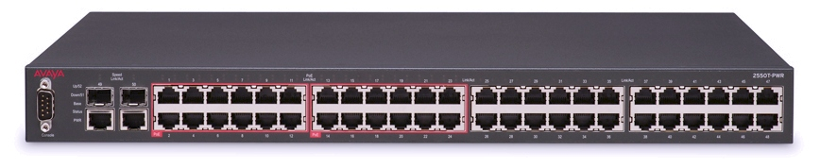

Fig:Switch

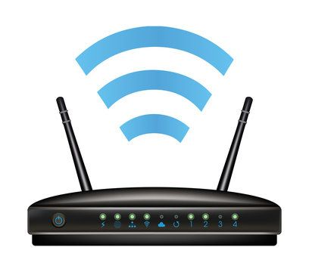

Fig:Router

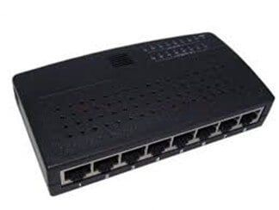

Fig:Hub

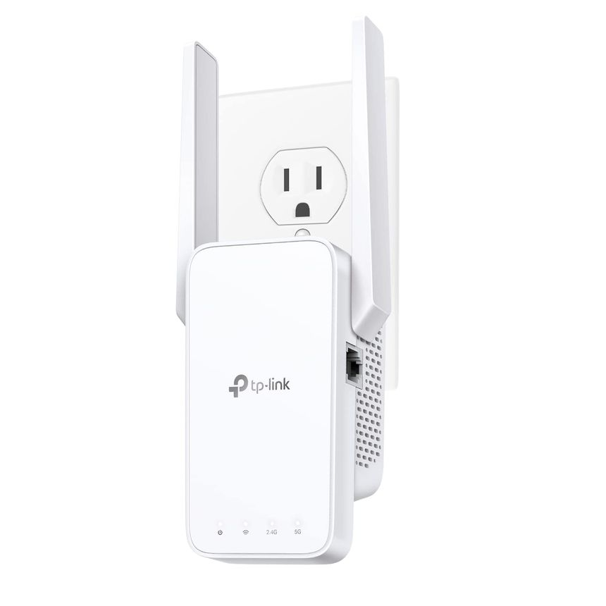

Fig:Repeater

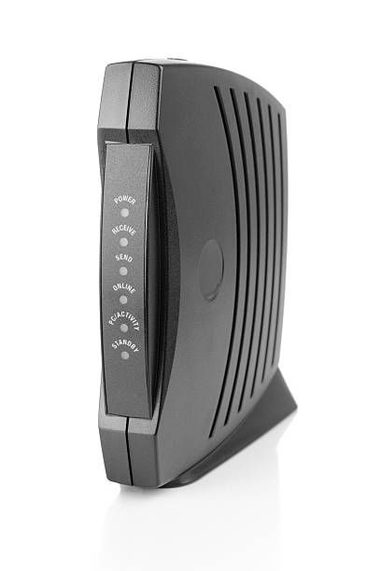

Fig: Modem

Networking Commands:

1. ipconfig: Commonly used to troubleshoot network connectivity problems. For instance, if a computer can't connect to the internet, using "ipconfig" helps check if it has a valid IP address, subnet mask, and default gateway.
2. ipconfig all: Useful for diagnosing more complex network issues. For example, when troubleshooting DNS-related problems, "ipconfig all" provides detailed information about DNS server settings and lease information obtained from a DHCP server.
3. nslookup: Frequently employed to resolve domain name-related issues. For instance, if a website isn't loading, "nslookup" can determine if the domain name is correctly resolving to the correct IP address, helping identify DNS configuration problems.
4. ping: Widely used to test network connectivity and measure latency. For example, when experiencing slow internet, "ping" can verify if the slow response is due to network connectivity issues or high latency between the local computer and a remote server.
5. hostname: Helpful for network identification purposes. For instance, in a corporate environment with multiple computers, "hostname" allows users or administrators to easily identify a specific computer on the network by its hostname.
6. tracert: Valuable for diagnosing network routing issues. For example, if experiencing intermittent connection problems to a remote server, "tracert" can reveal which network hops are causing delays or packet loss, aiding in troubleshooting network routing problems.
7. netstat: Often used to monitor network connections and diagnose network-related problems. For instance, if a computer is suspected of being infected with malware, "netstat" can reveal suspicious network connections or open ports, helping detect and mitigate security threats.
8. arp: Useful for troubleshooting connectivity problems and detecting network attacks. For example, if experiencing intermittent network disconnections, "arp" can verify if there are incorrect ARP mappings or ARP cache poisoning attacks on the local network, allowing for prompt resolution of such issues.

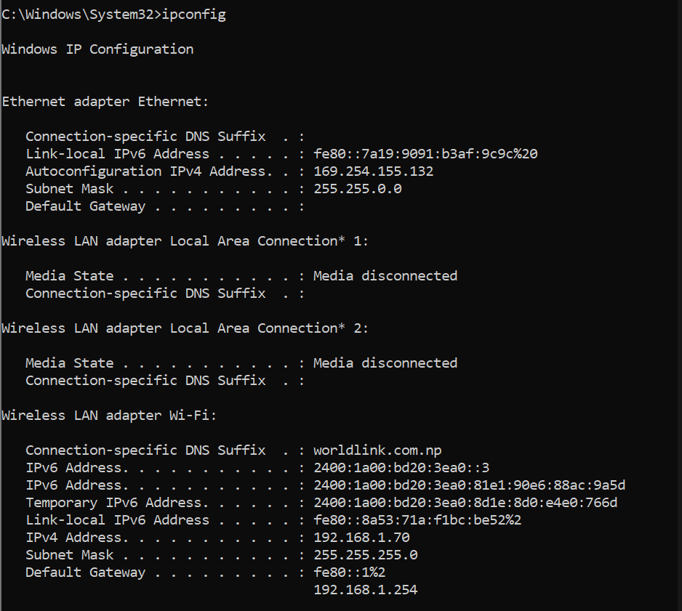

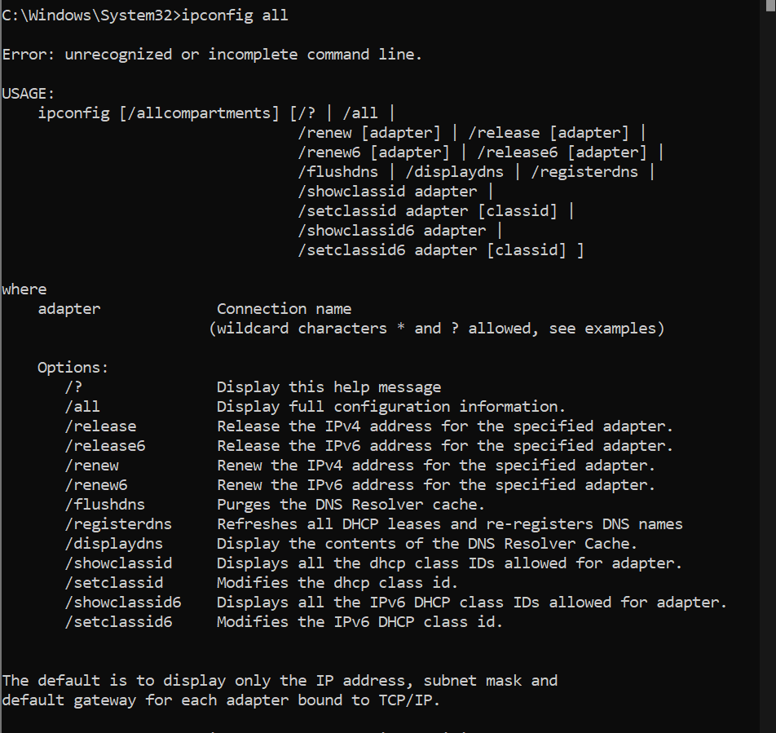

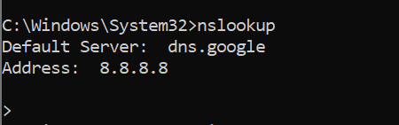

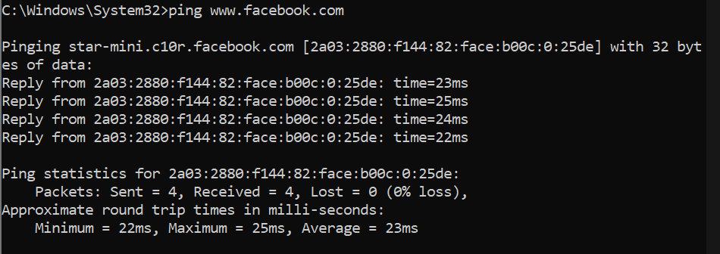

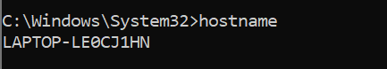

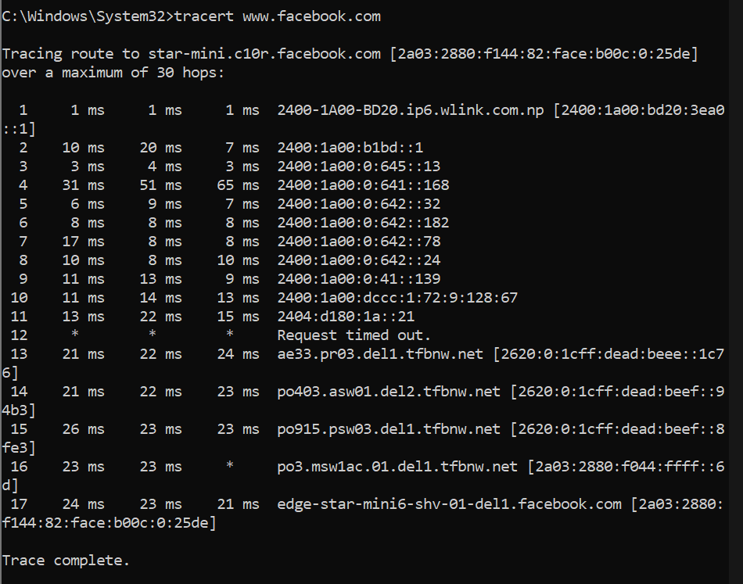

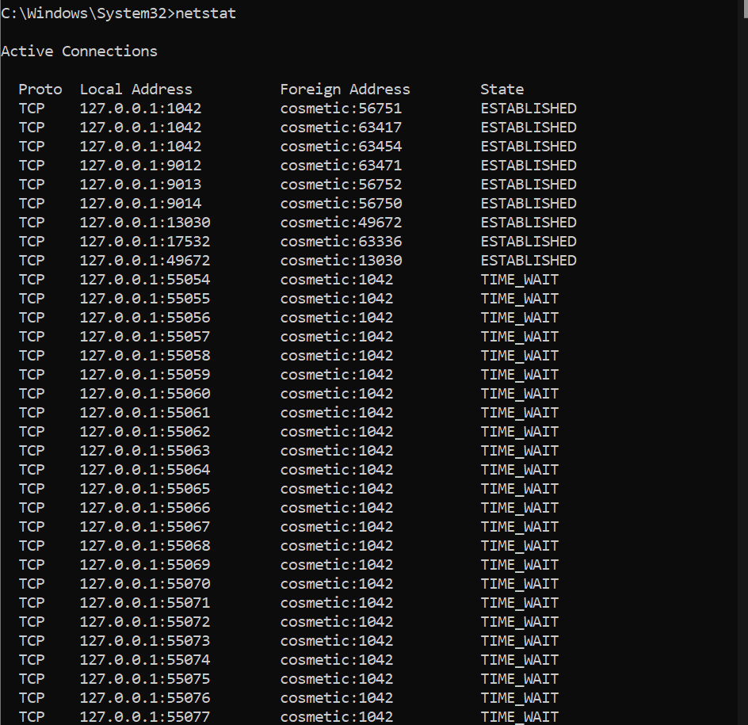

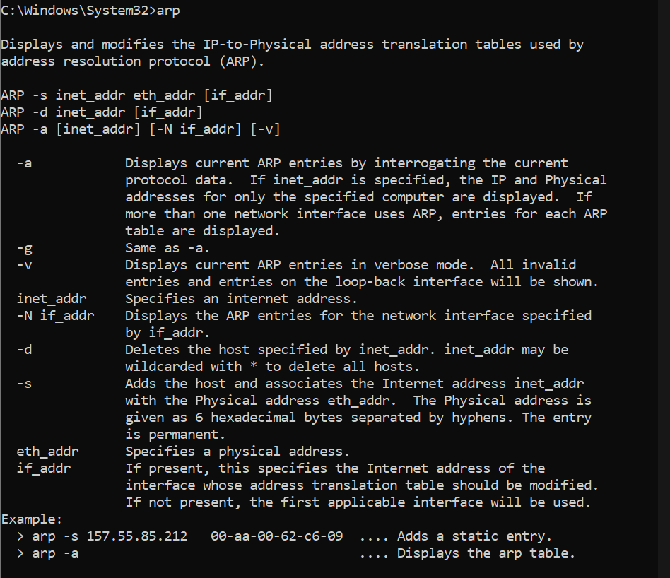

Implementing of static and dynamic IP address in computer.

Static:

1. Go to settings:

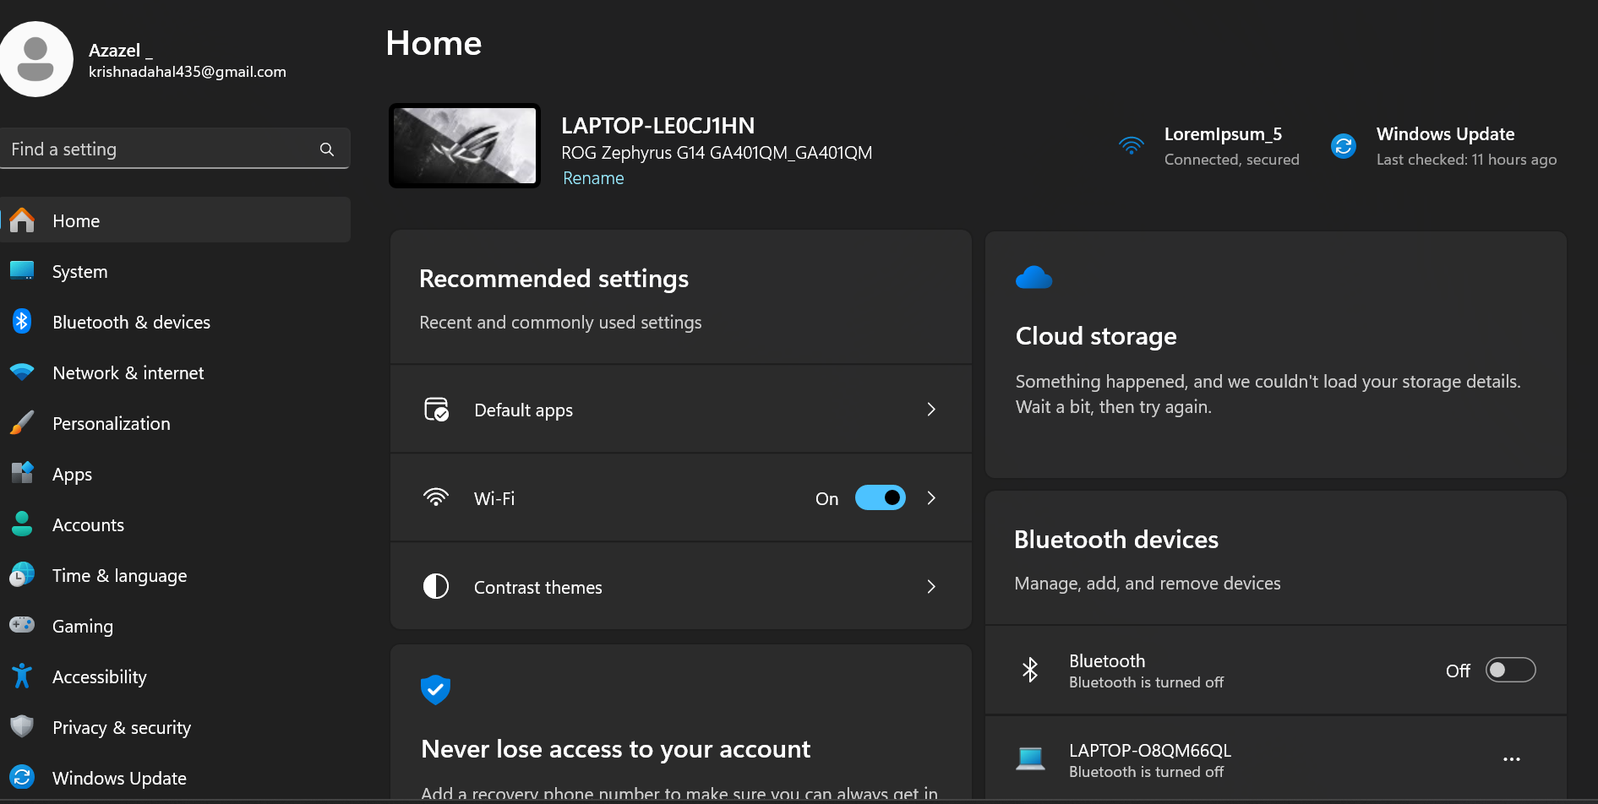

1. Go to Network & Internet 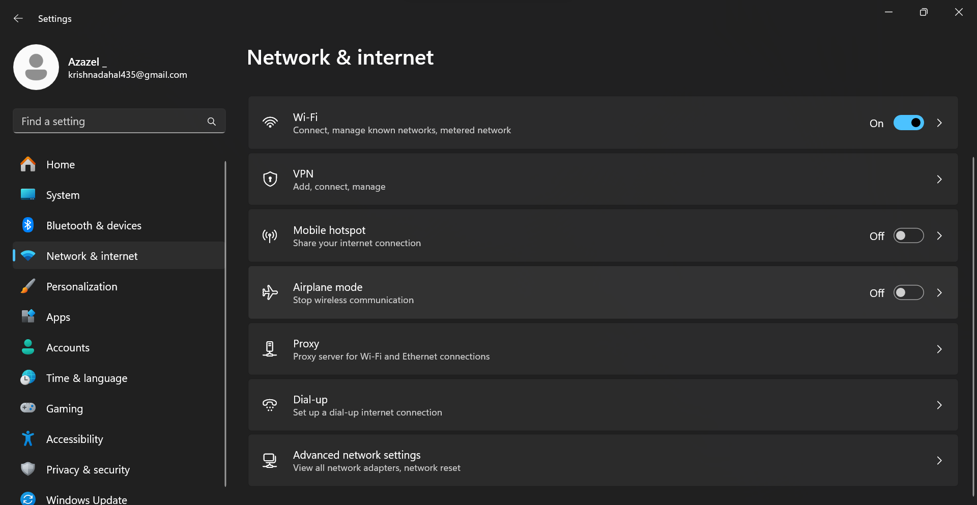
2. Go to Advance network settings and click on edit of WiFi 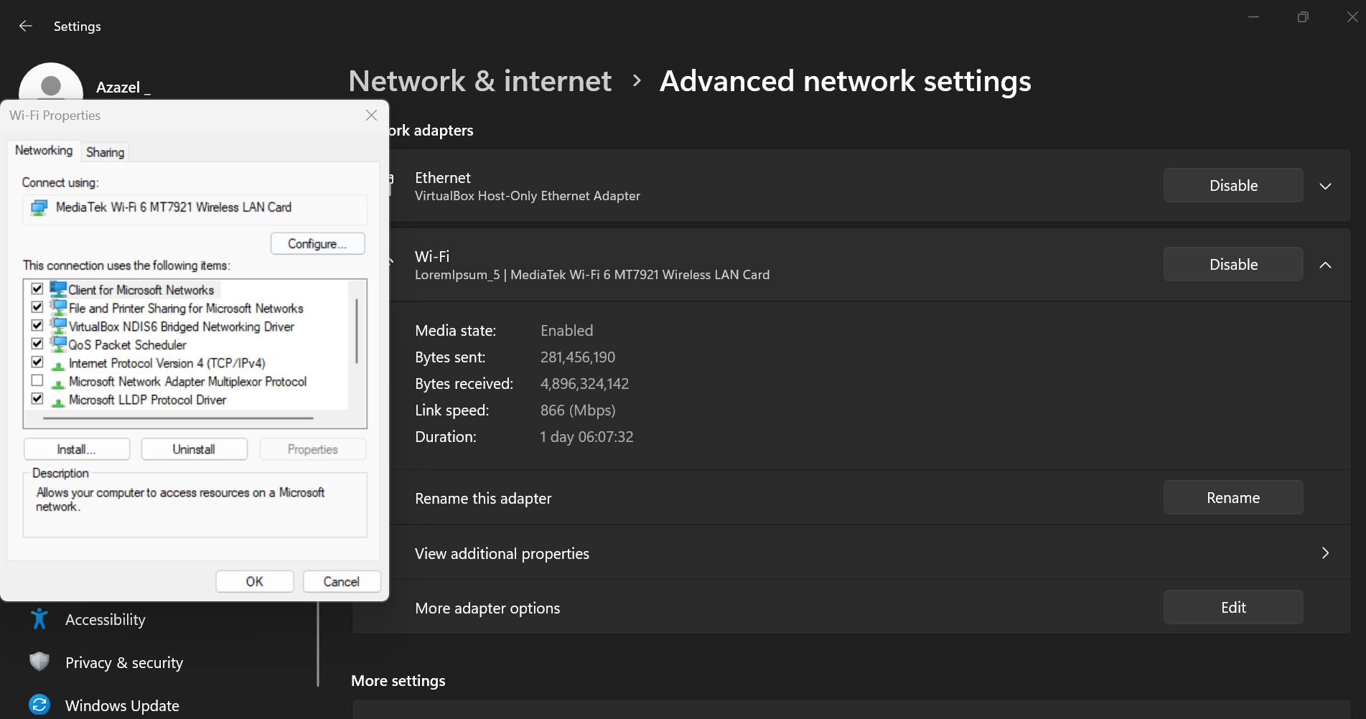
3. Click on Internet Protocol version 4 (TCP/IPv4) 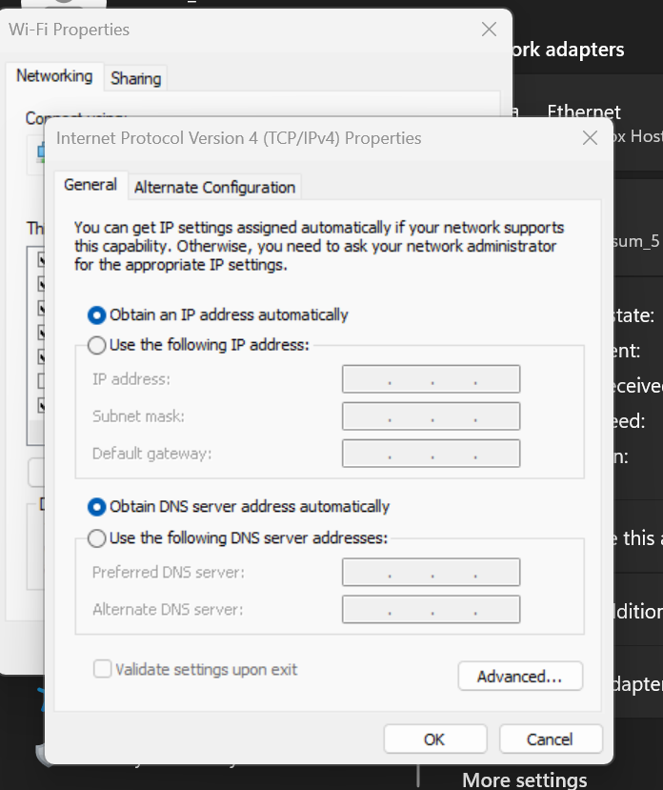
4. Check on use the following IP address and input given input in fields>Press OK: 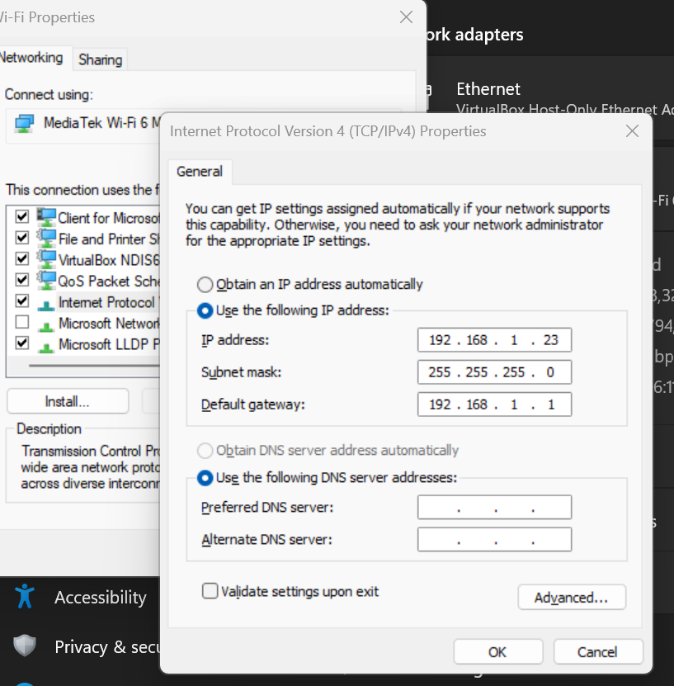

Dynamic

1. Click on Internet Protocol version 4 (TCP/IPv4) 
2. Check on Obtain an IP address automatically >Press OK: 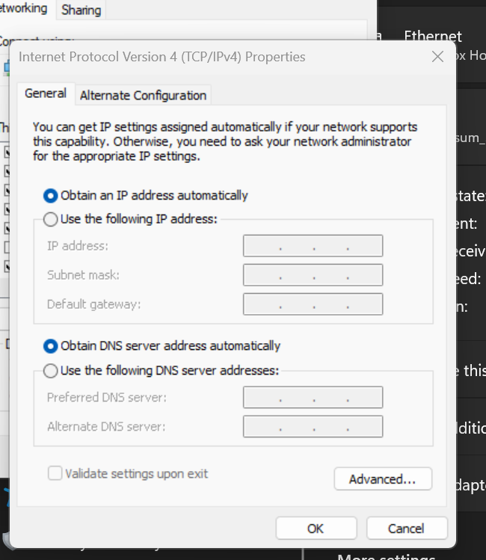

Cisco packet tracer download:

1. Visit the official website of [Netacad](https://www.netacad.com/" \t "https://www.geeksforgeeks.org/how-to-install-cisco-packet-tracer-on-windows/_blank) using any web browser &  Press the login button and select log In option. 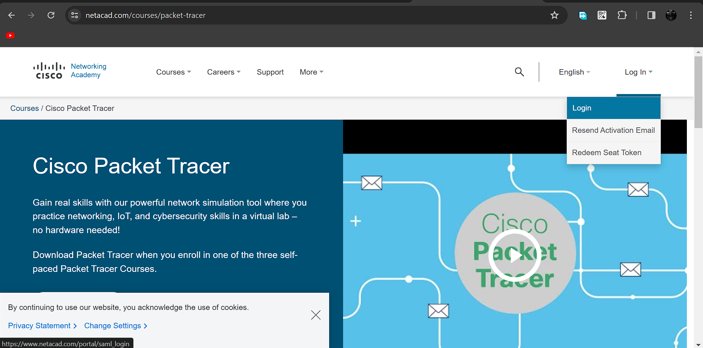
2. Next screen will appear, click on the sign-up option. 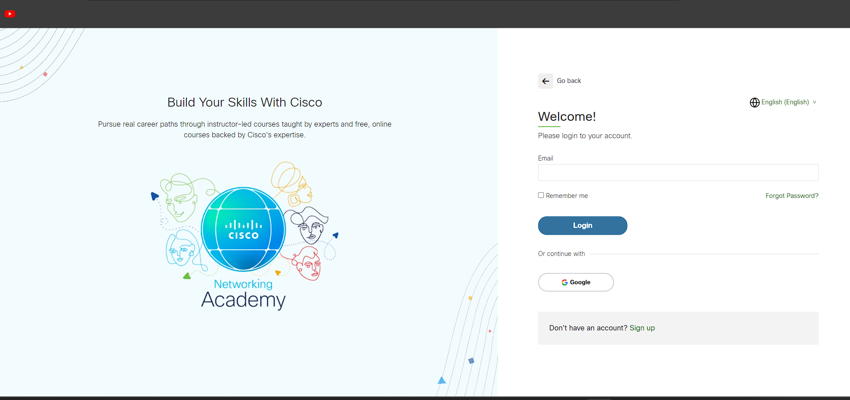
3. Next screen will appear and will ask for email and password and other simple details, fill them and click on Register. 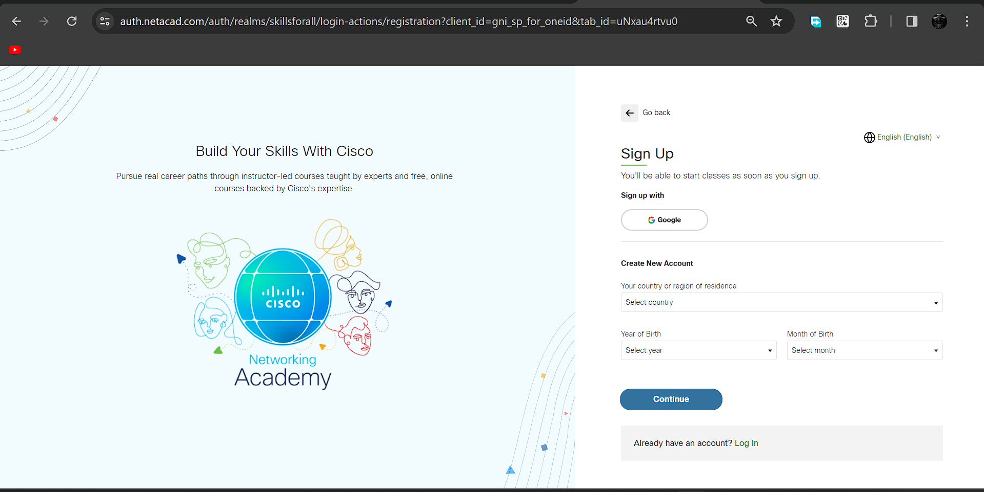
4. Now the login screen appears again so fill in the Email id & On the next screen enter the password and press the Login button. 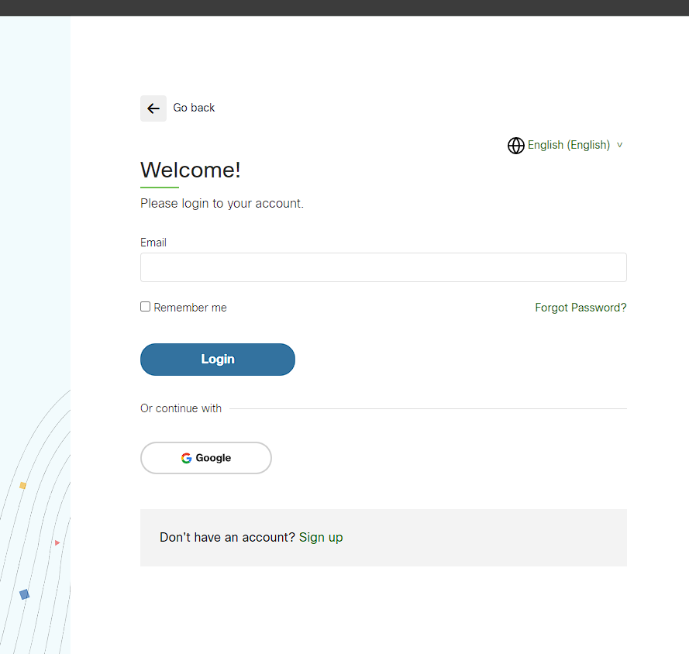
5. Dashboard will initialize, now click on Resources and choose Download Packet Tracer Option.  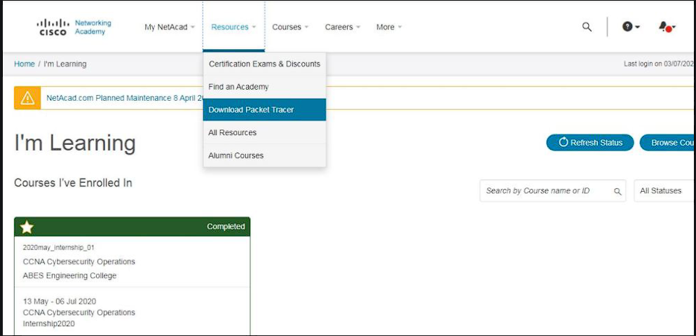
6. On the next web page choose the operating system to download the packet tracer. Downloading will start automatically.

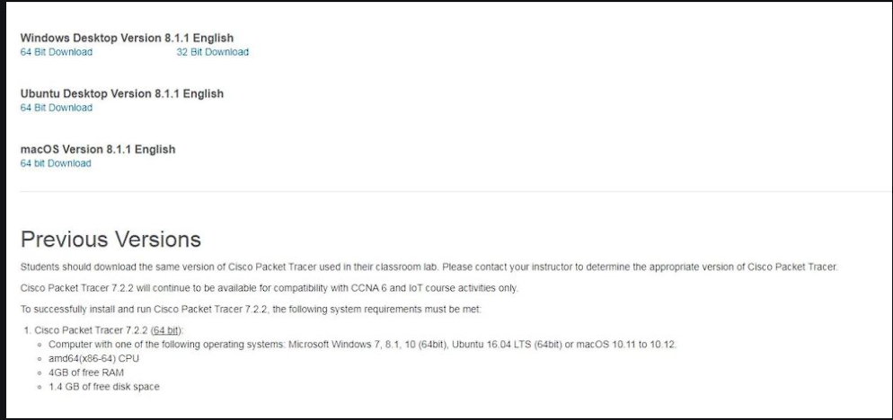

1. Check for the executable file in your system and run it. Next screen is of License Agreement so Click on I accept the license.

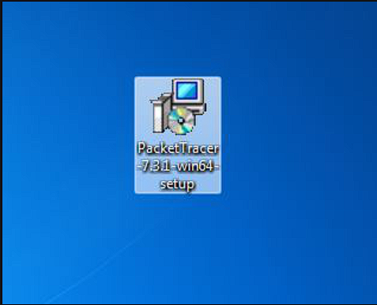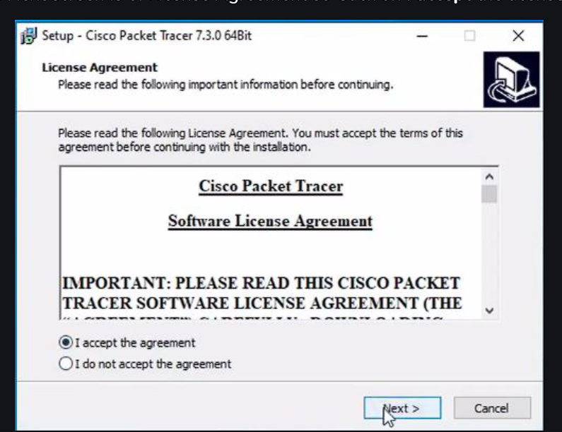

1. Choose the installing location which has sufficient space. 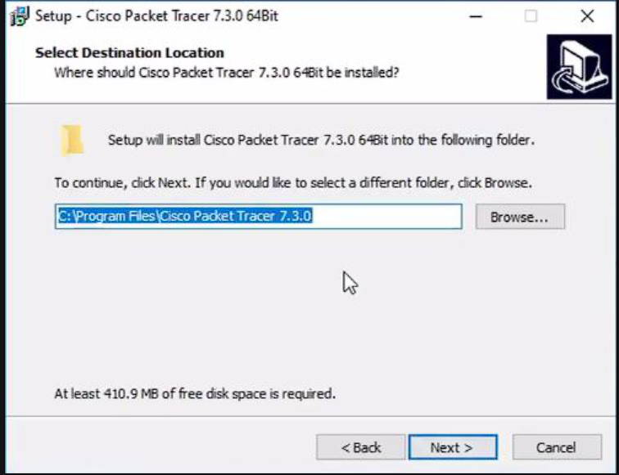
2. Select the start menu folder and click the Next button 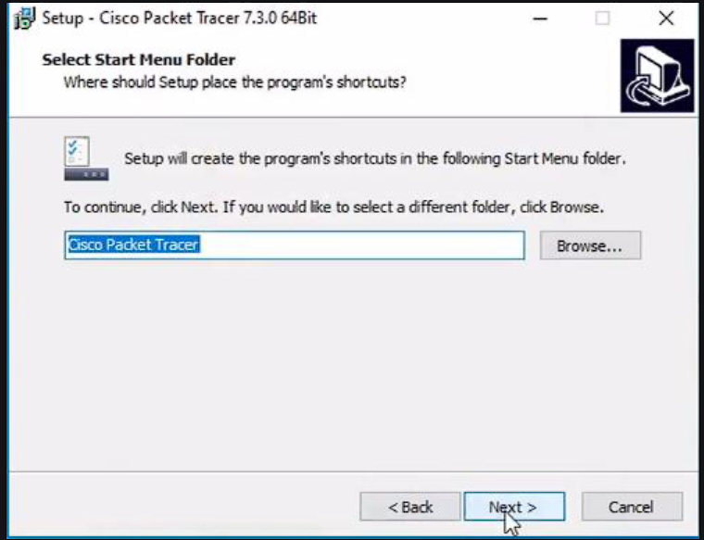
3. Check the box for creating a desktop icon and click on the Next button. 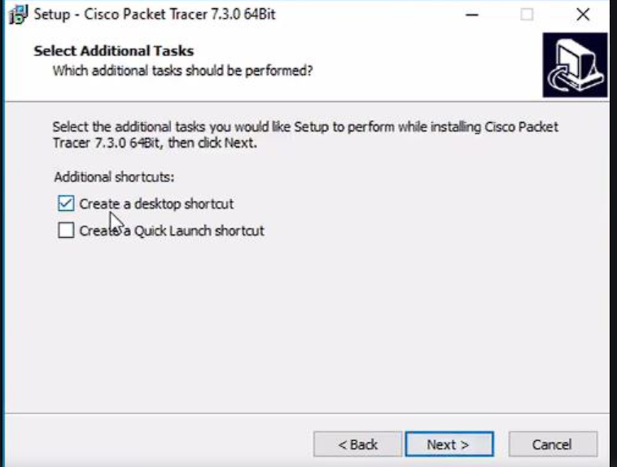
4. Now packet tracer is ready to install so click on the Install button

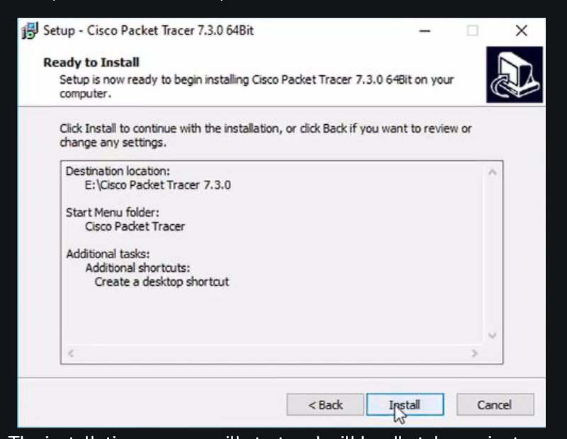

1. After the installation is completed click on the Finish button to complete the installation. 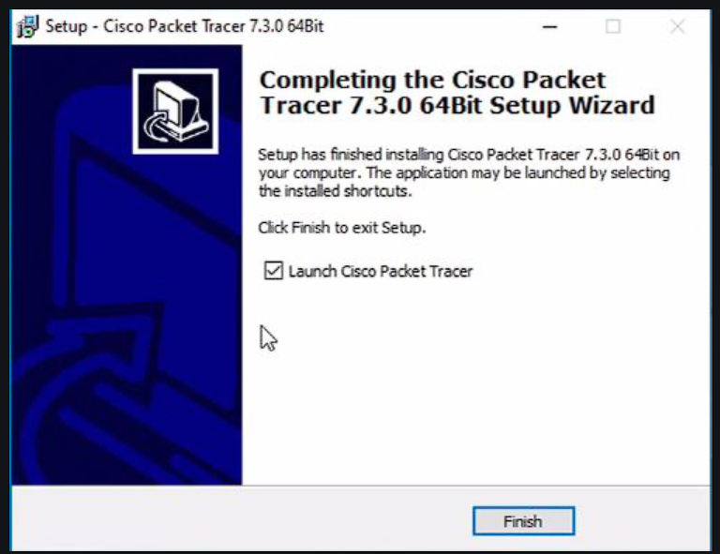
2. Interface is initialized and the software is ready to use.

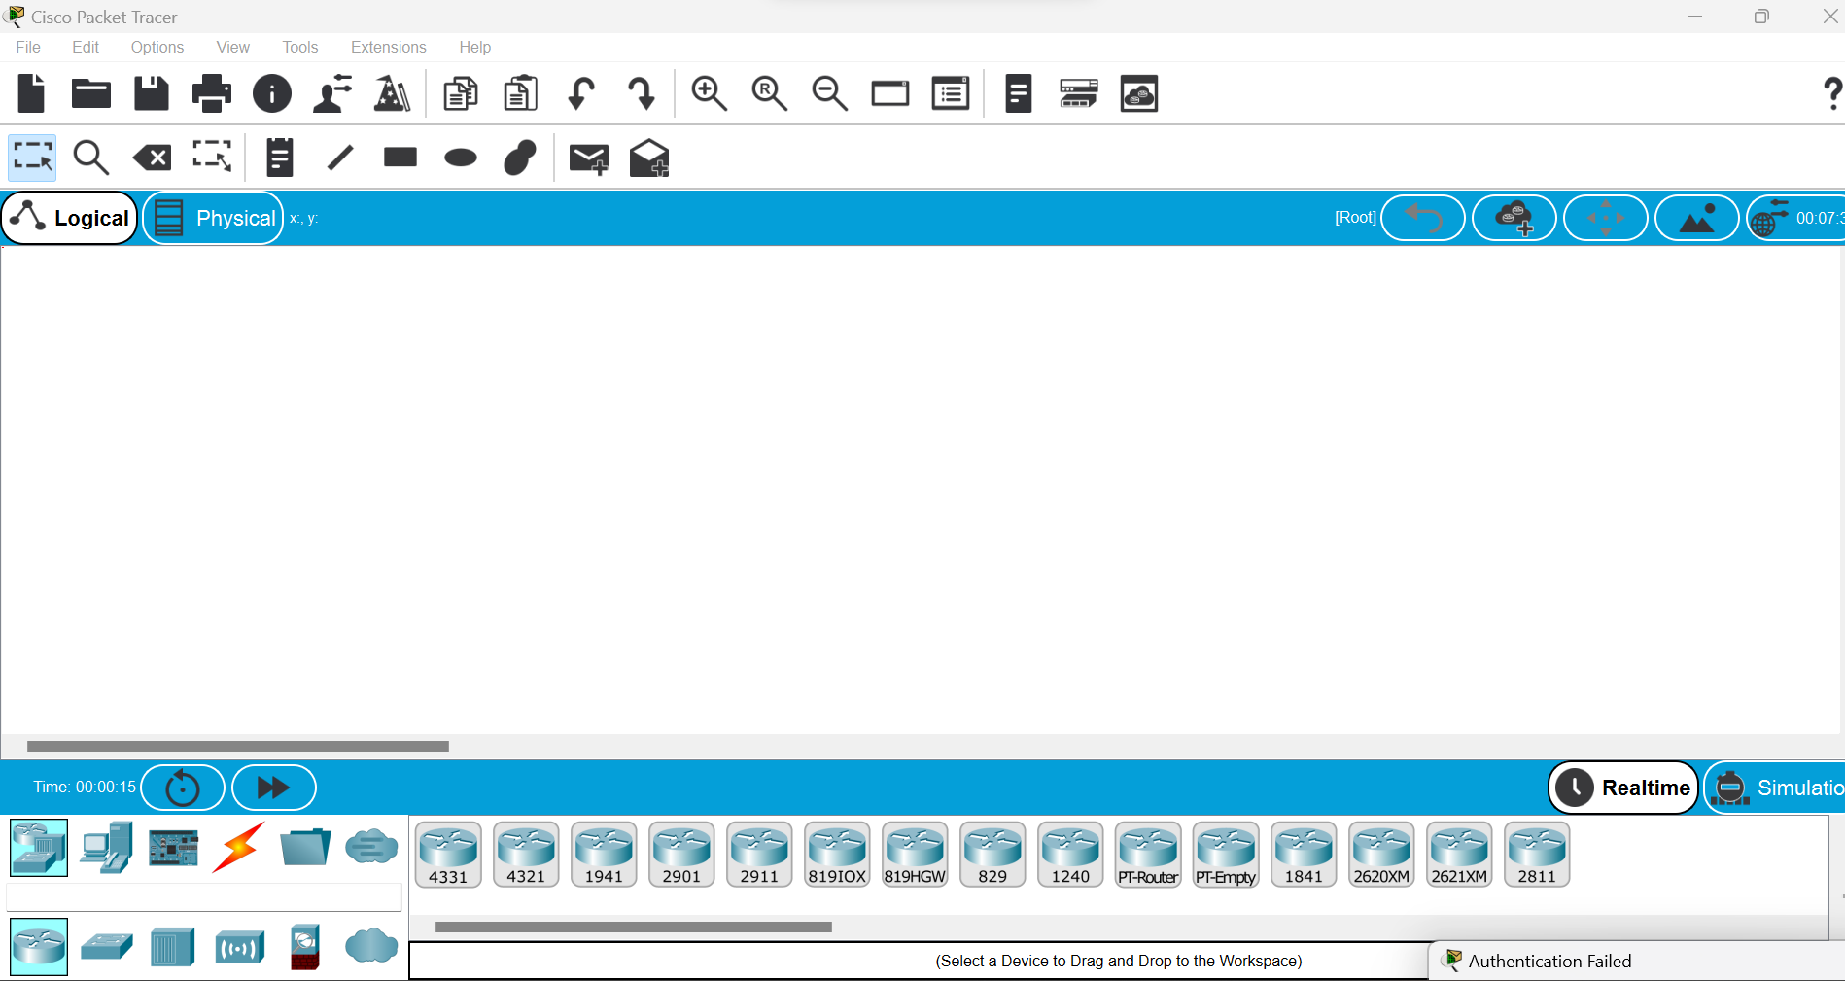

functional uses of Cisco Packet Tracer:

1. E-learning
2. visualizing networks
3. real-time and simulation mod
4. compatible on various platforms
5. support to all languages
6. most networking protocols are supported
7. environment is interactive.
8. can be used on unlimited devices
9. the main purpose of it is to help students learn the principles of networking with hands-on experience
10. its used to demonstrate the technical concepts and networking systems.
11. it makes the job easier for engineers allowing them to add or remove simulated network devices, with a command line interface and a drag and drop user interface

Implement the uses of subnet masks(static IP-design) with a switch and two end devices.

* Start
* Take two host and a switch for network connection between them
* Connect them using connecting wire
* Configure IP statically of one end devices.
* Enter the class-c ip address at Pv4 and sub-net it making only 2 valid host(/30)
* Pass the message packet from one end device to other end device.
* Ping any one device ip address using command prompt
* End.

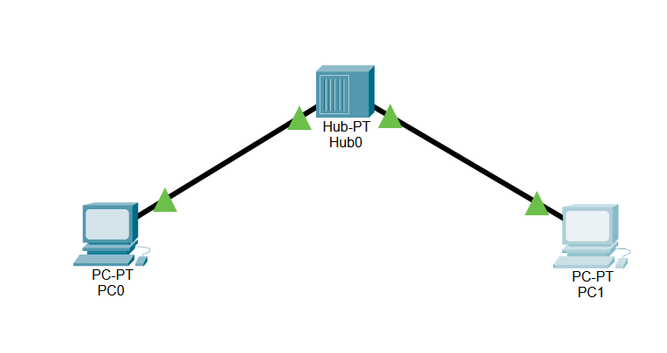

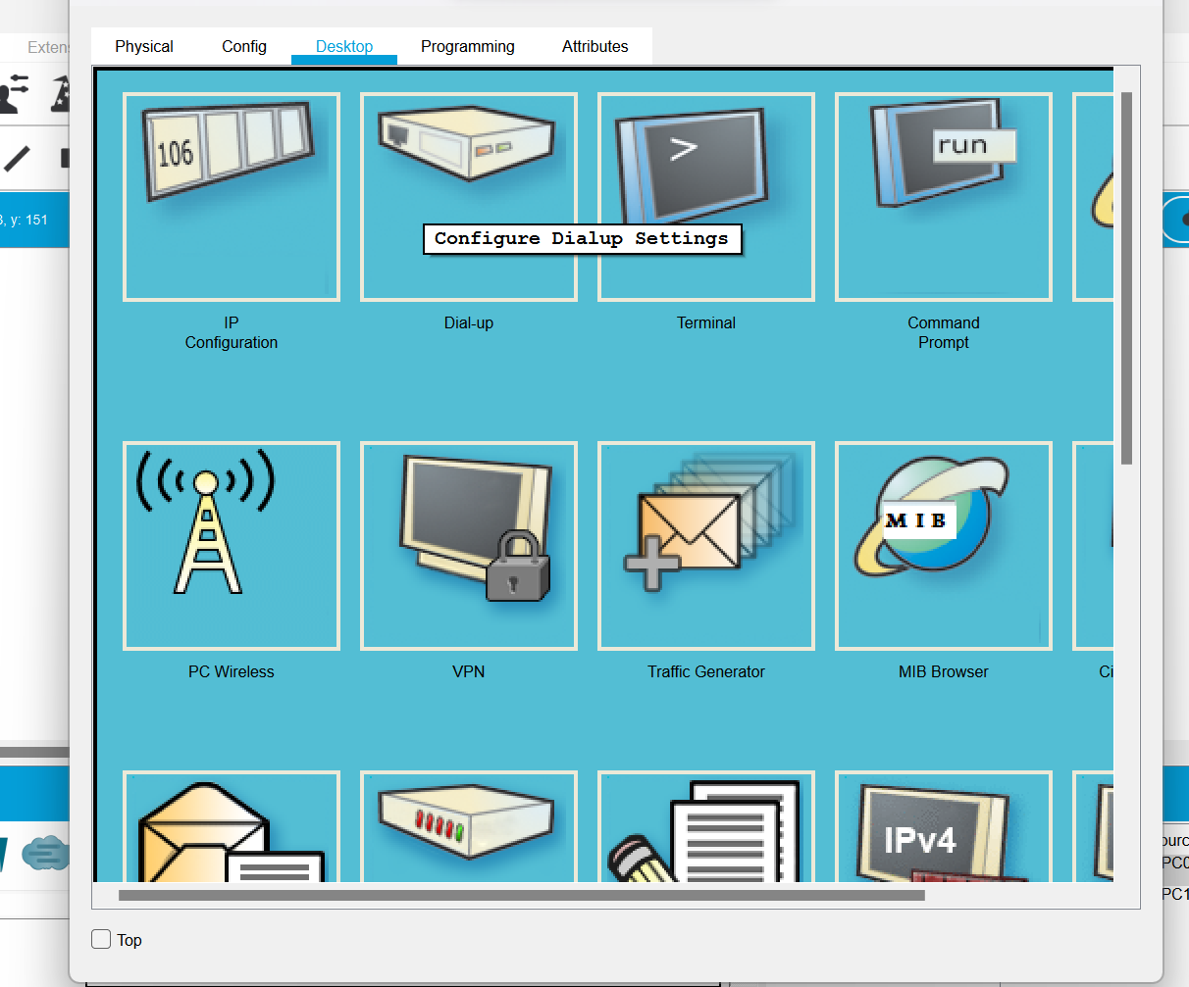

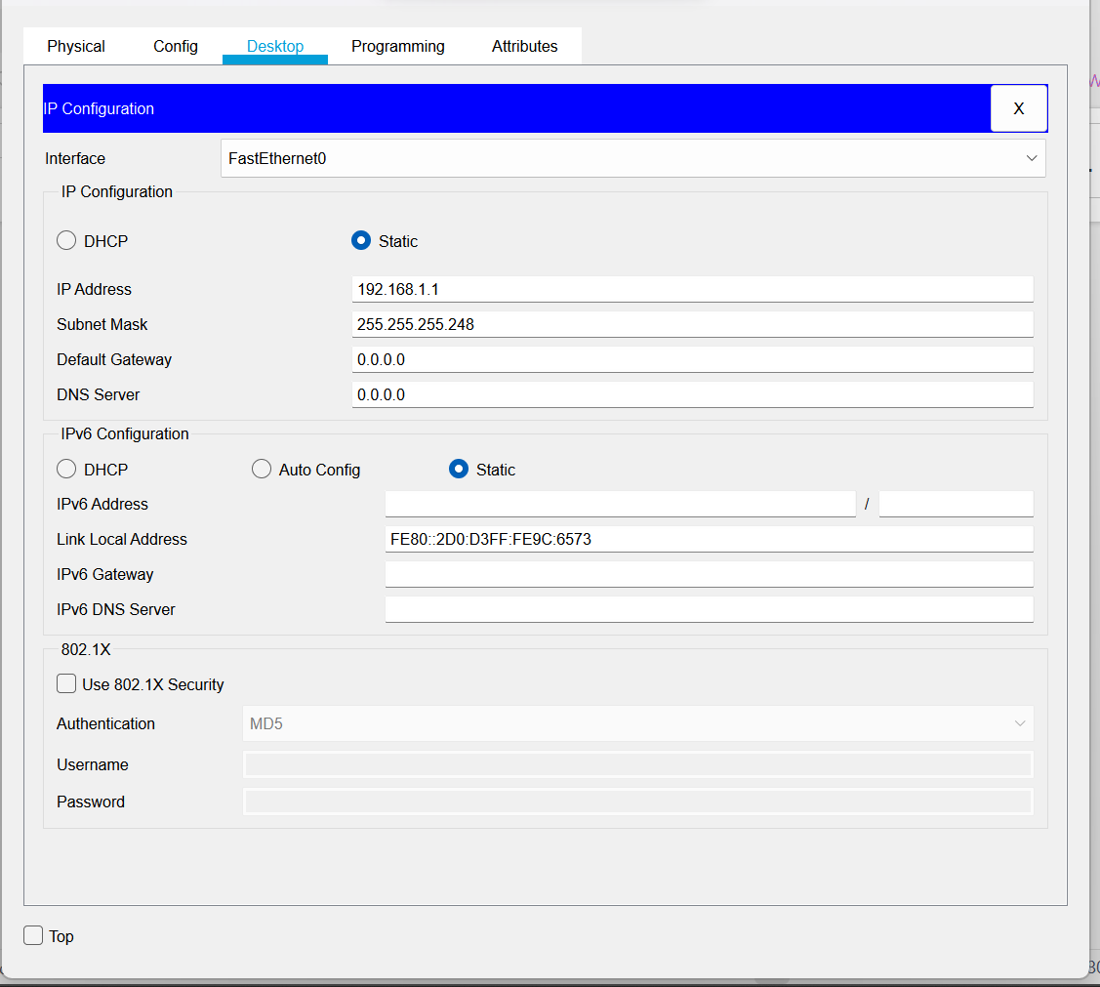

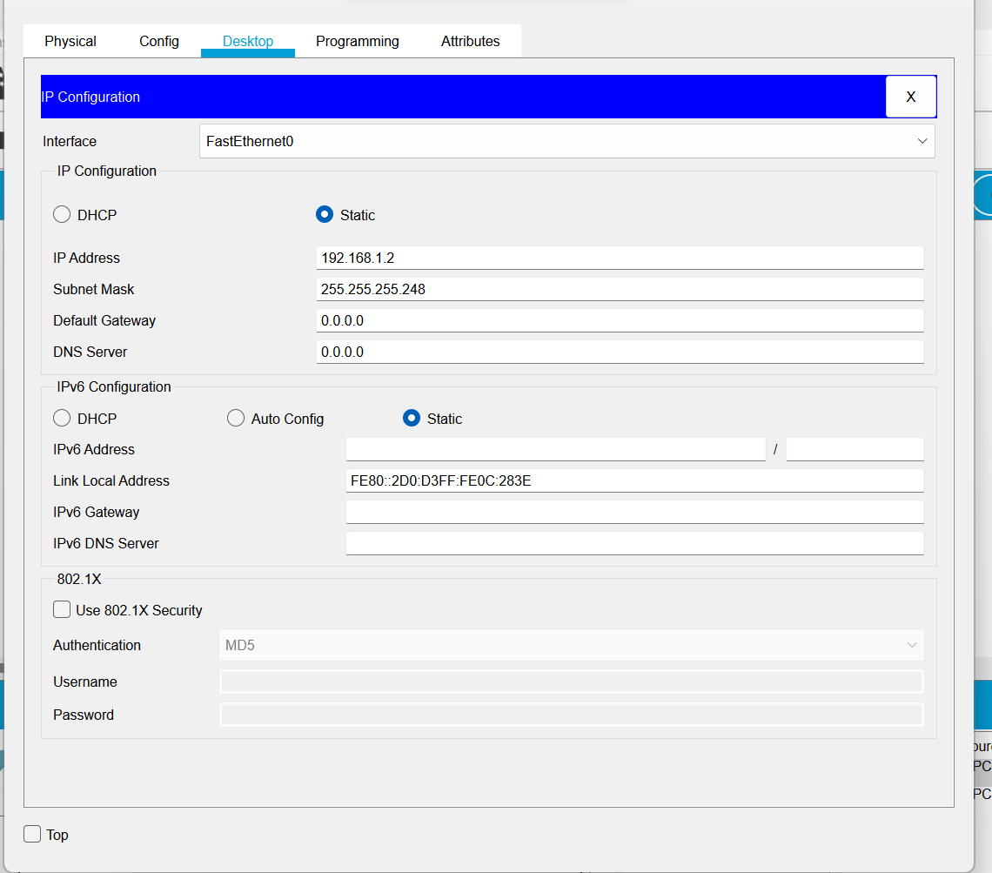

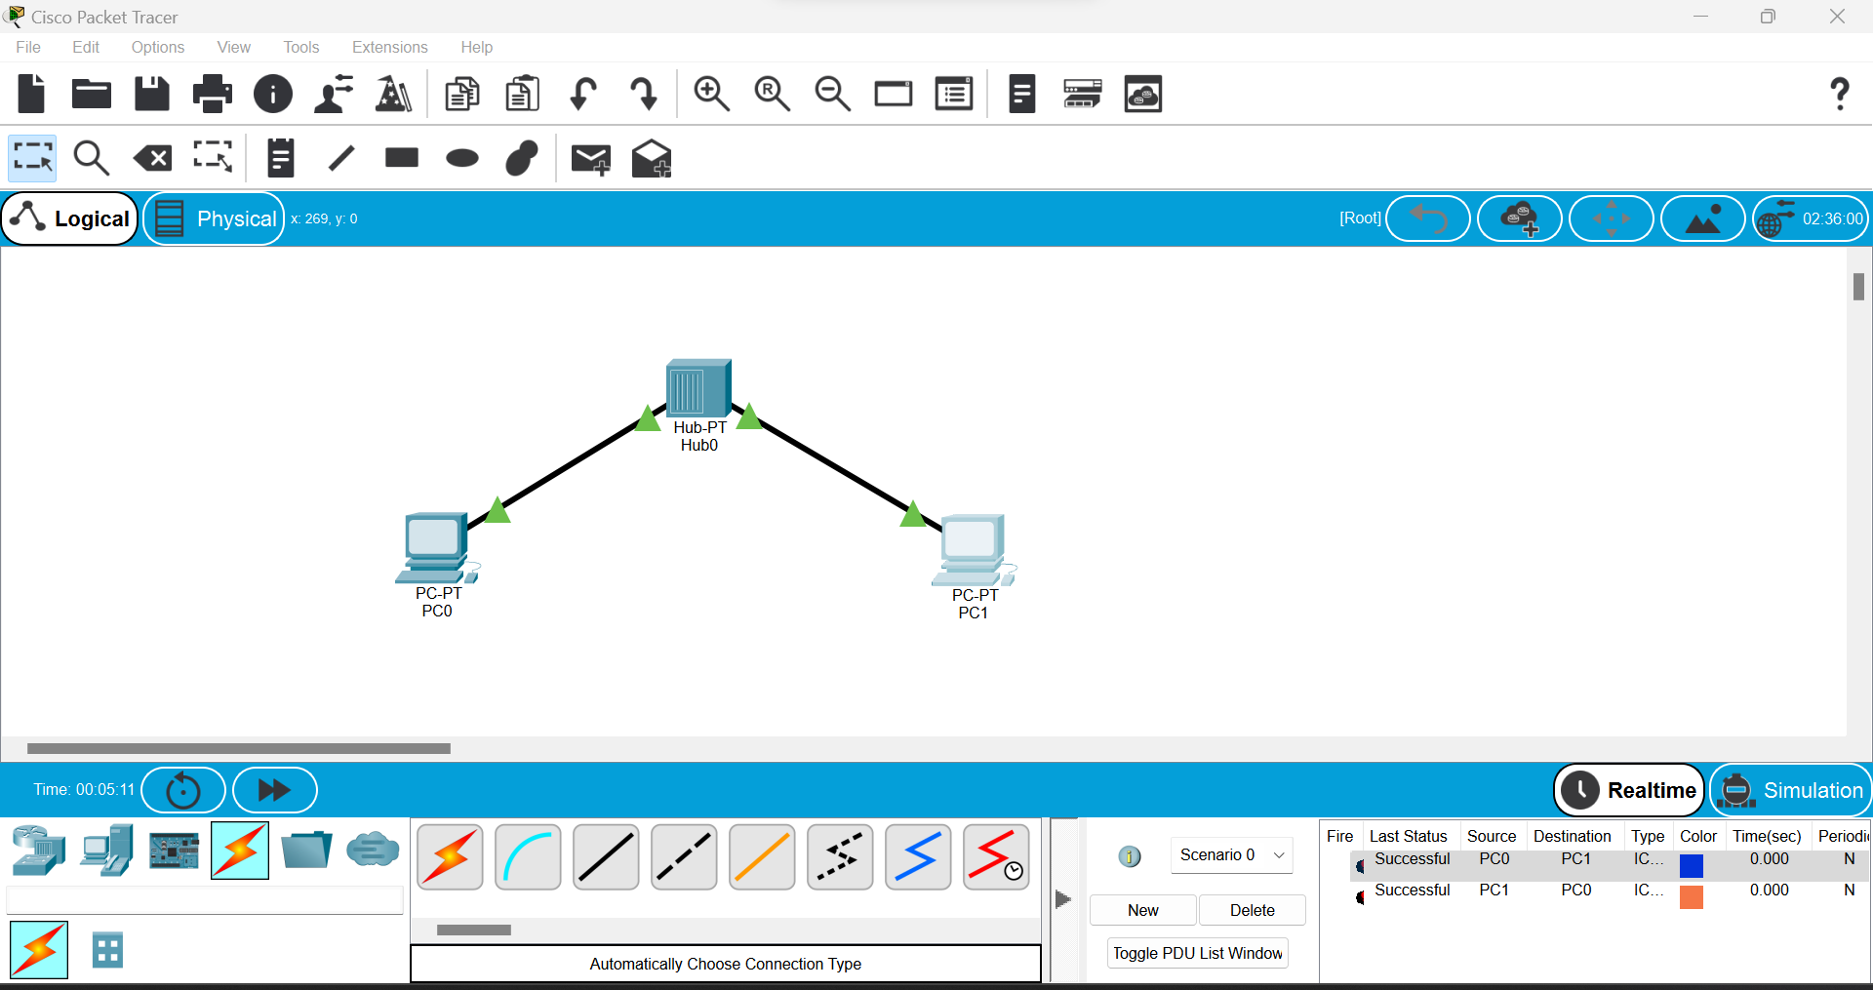

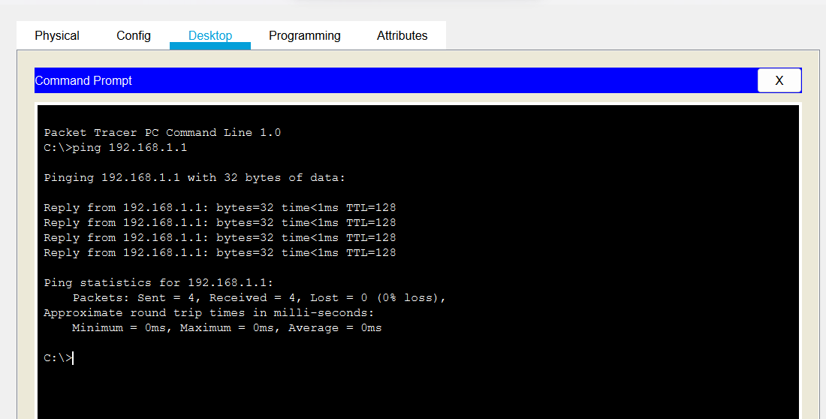

Switch hub and end devices

* Start
* Take 3 host/end devices,a hub and a switch for network connection between them
* Connect them using connecting write.
* Configure Ip statically of each end devices
* Enter class-c Ip address at ipv4 and sub-net it(/24)
* Repeat step 3-4 for other end devices
* Pass the message packet from one end devices to other end devices
* Ping any one device IP address using command prompt
* End

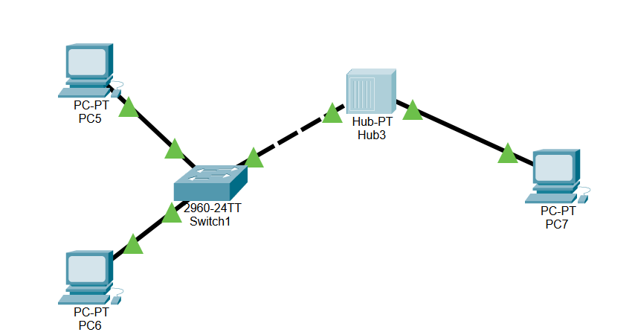

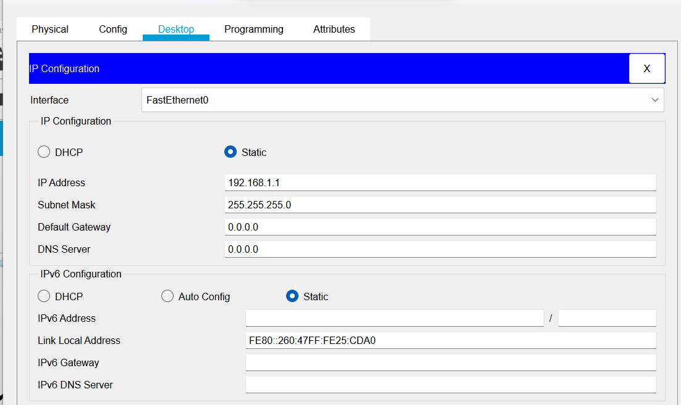

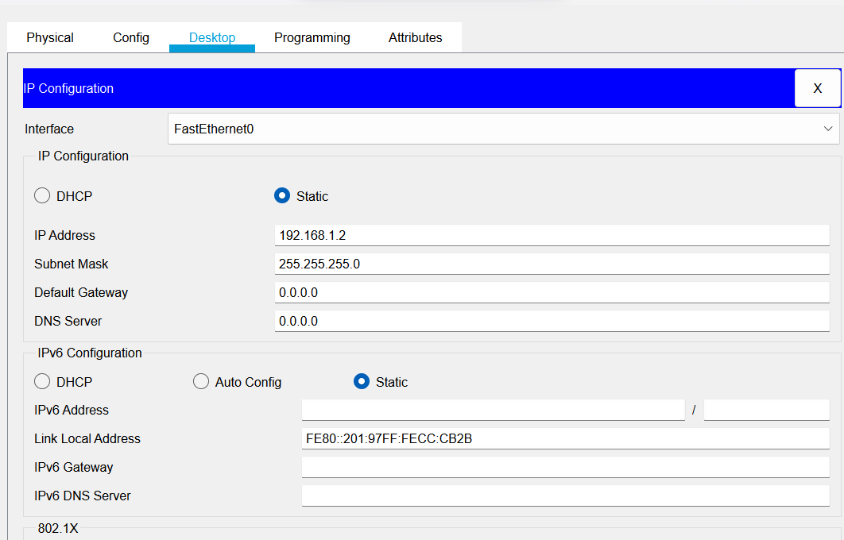

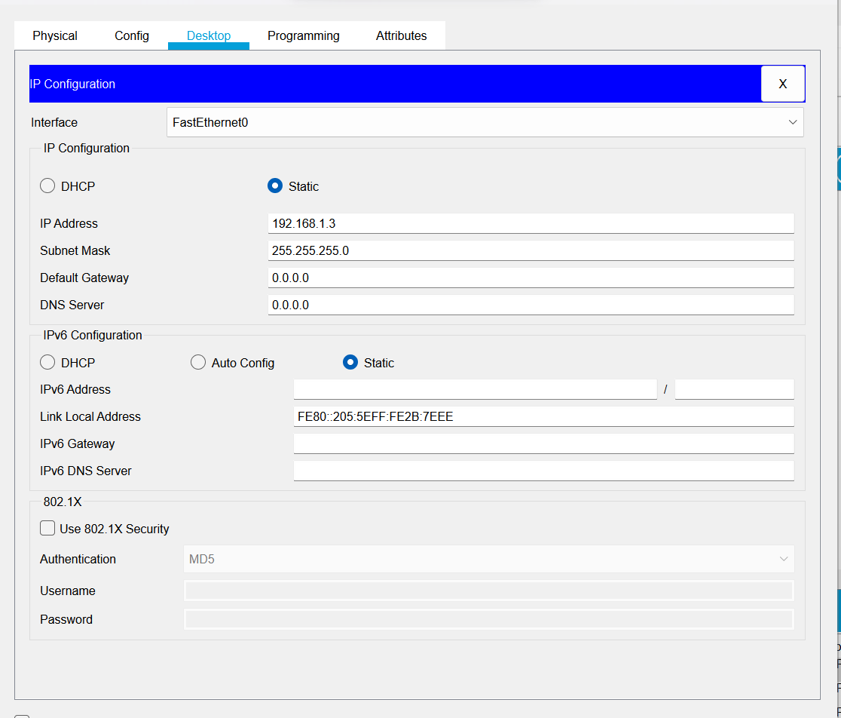

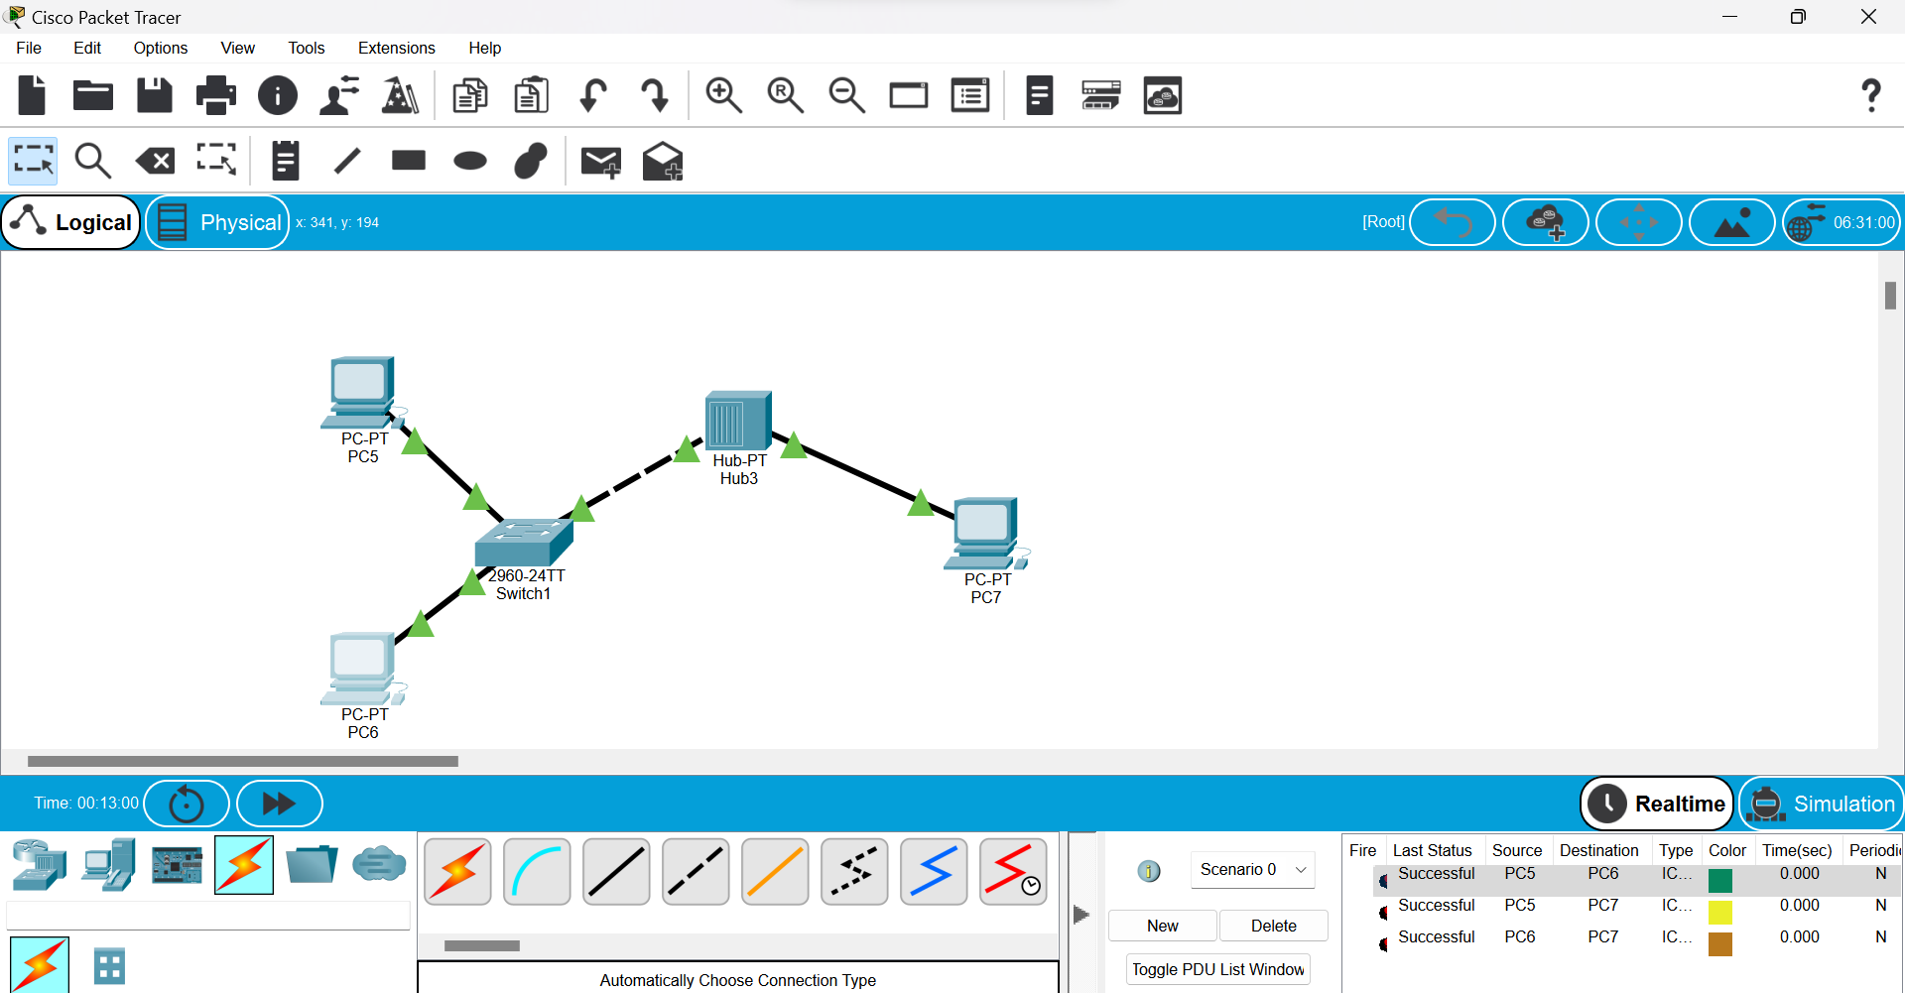

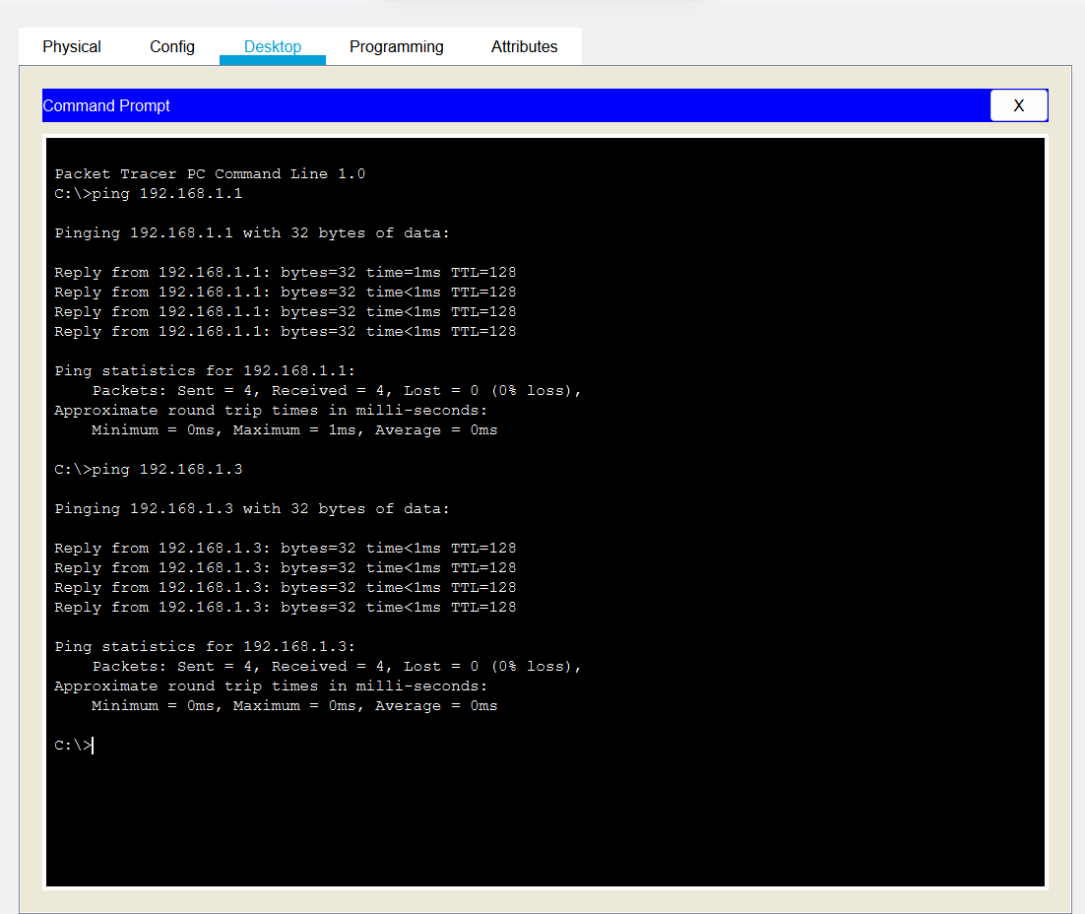

Server,switch, hub and end devices

* Start Take 2 Host, a server & a switch for network connection between them.
* Connect them using connection wire.
* Click on server>services>HTTP an make both HTTP and HTTPS on.
* Click on DHCP and turn on services
* Enter the starting IP address and its subnet mask and save it.
* No, server>Desktop and configure the IPv4 address in statically.
* Click on end device>Desktop and turn on DHCP(server will automatically generate the IP address for end device)
* Repeat step 7 for each end device.
* Pass the message packet from one end device to other end device(if it shows successful the design is valid and error less)
* Ping any one device IP address using command prompt
* End

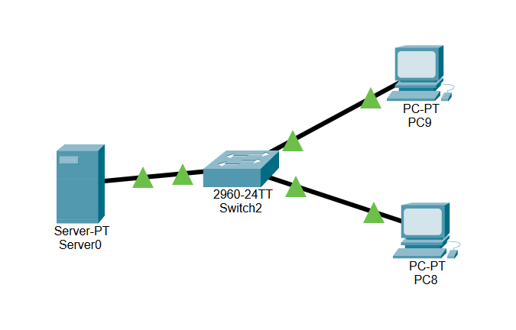

Server:

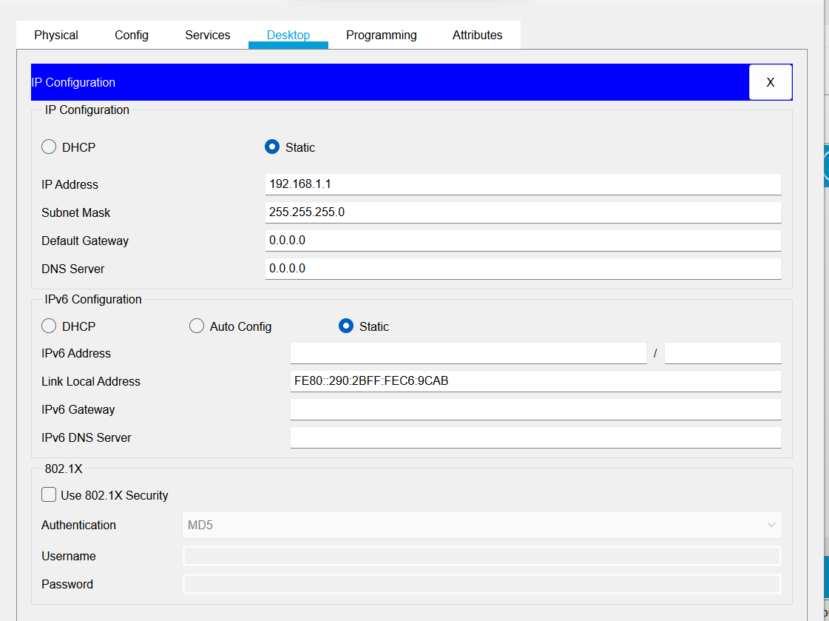

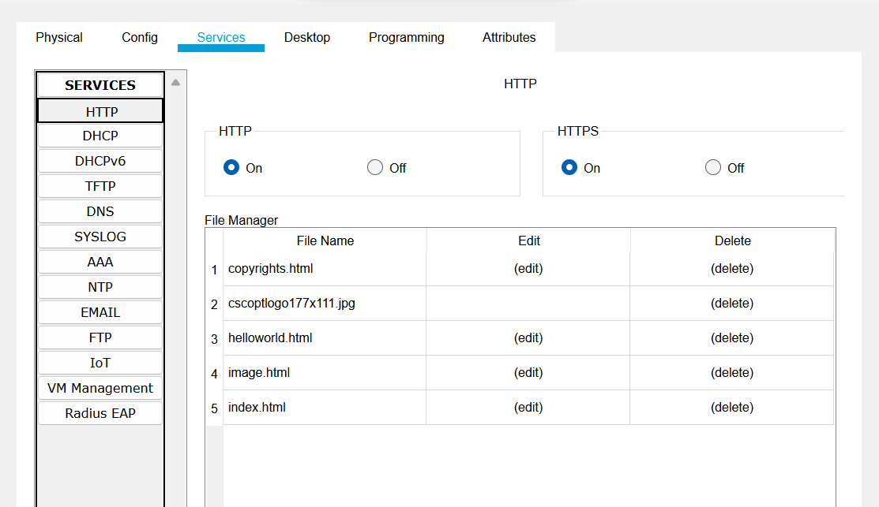

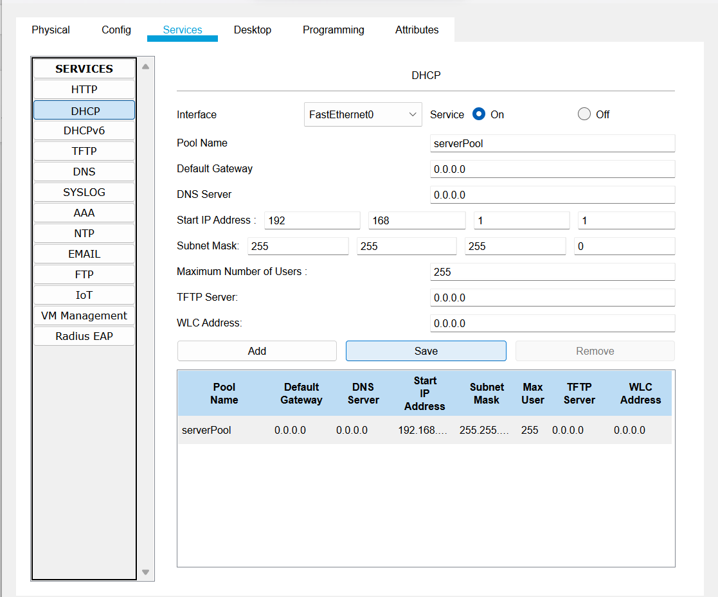

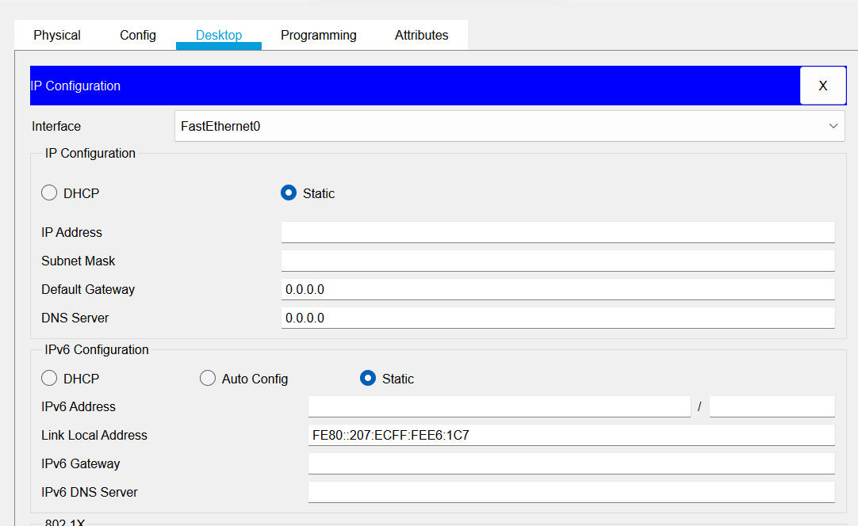

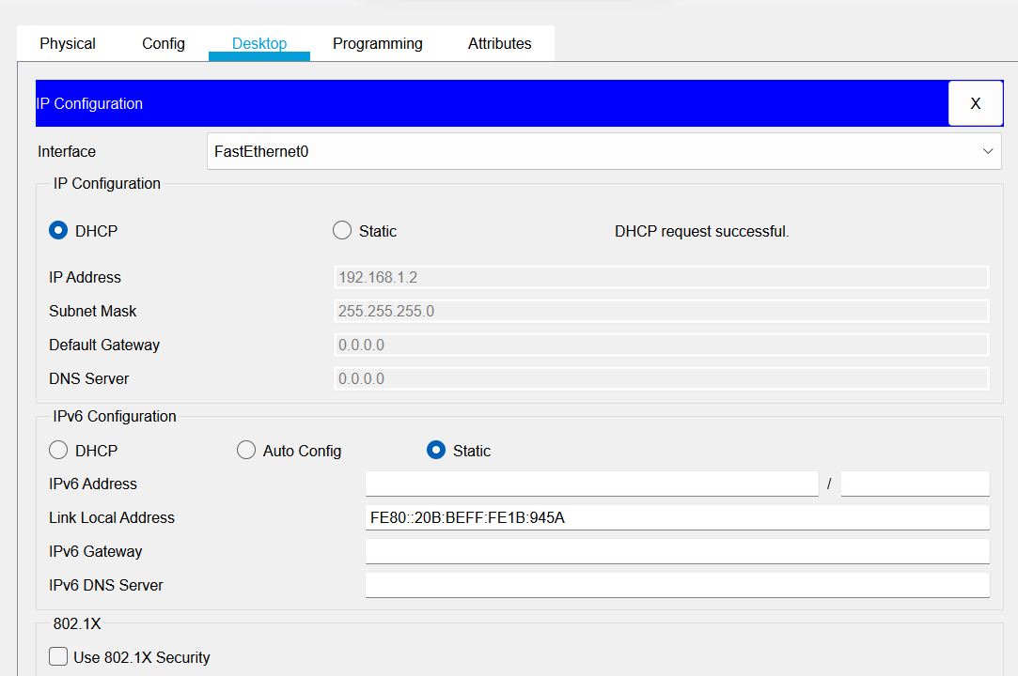

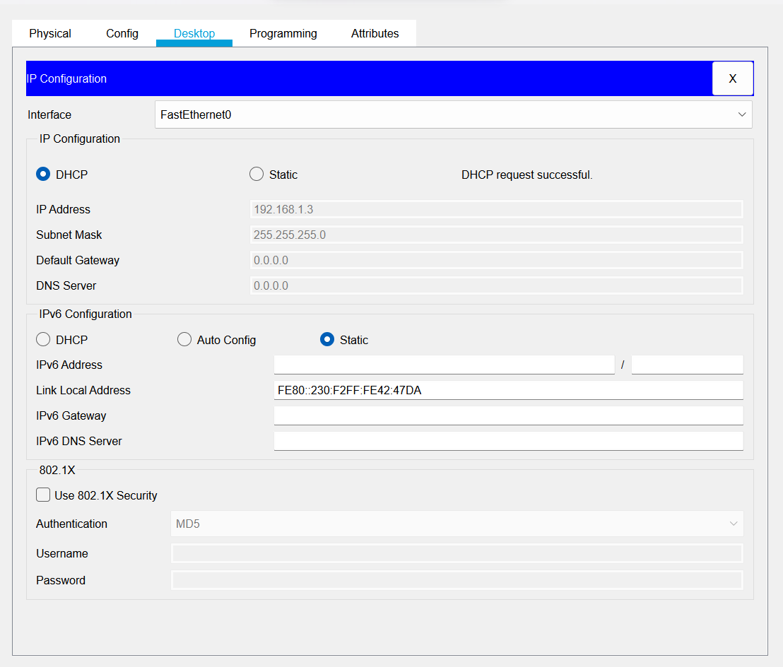

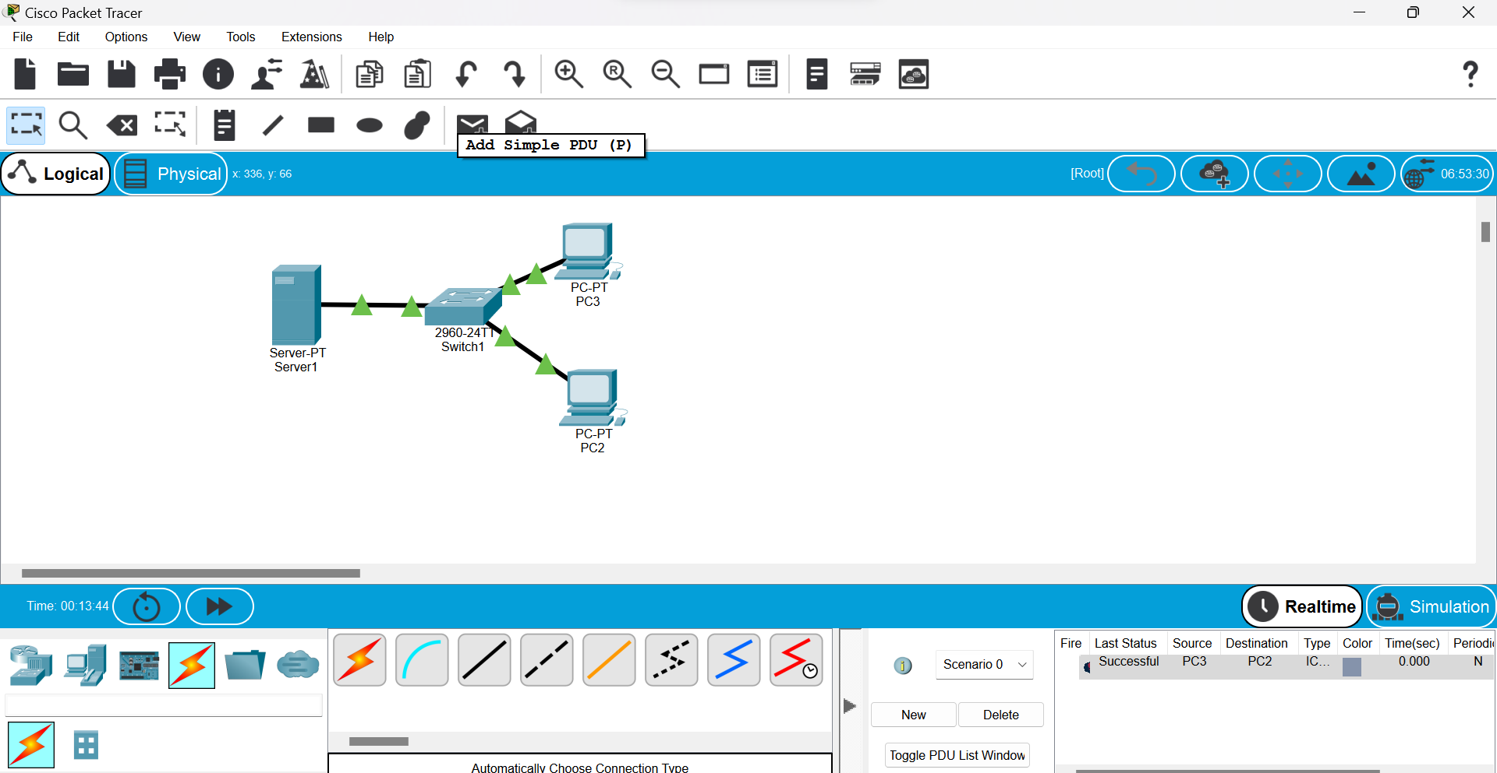

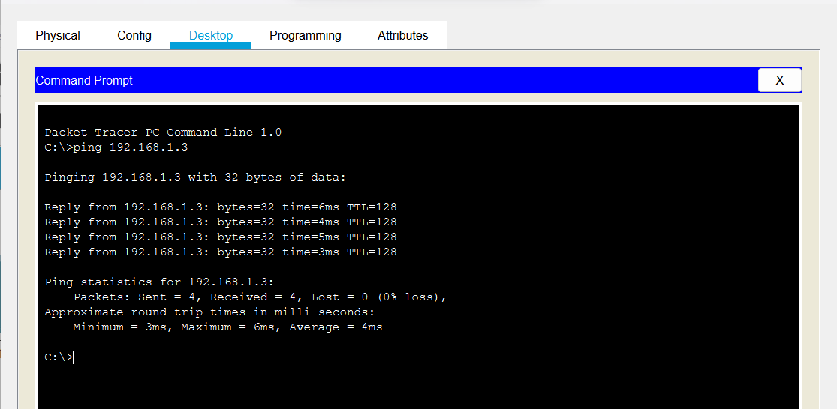

DNS:

1. Start
2. Take 1/2 host, a server and a switch for network connection between them.
3. Connect them using connection wire.
4. Click on server>IP configuration and set its IP statically:(192.168.1.1) and give DNS server address:(192.168.1.1)
5. Click on server>services>HTTP and make both HTTP & HTTPs on.
6. Click on edit of index.html and edit its content and save it.
7. Click on DNS and turn it on.
8. Give name:(www.test.com) and DNS server:(192.168.1.1)
9. Give static IP address to hosts and give the same DNS server:(192.168.1.1)
10. Click on host>desktop>web browser and search with DNS name/server i.e. (www.test.com)/(192.168.1.1)
11. End

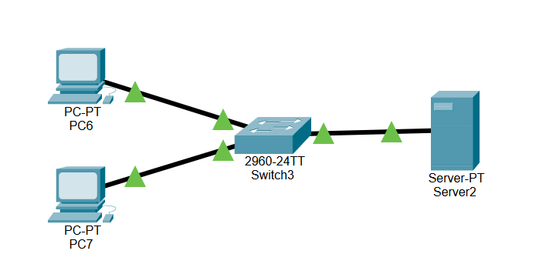

Server:

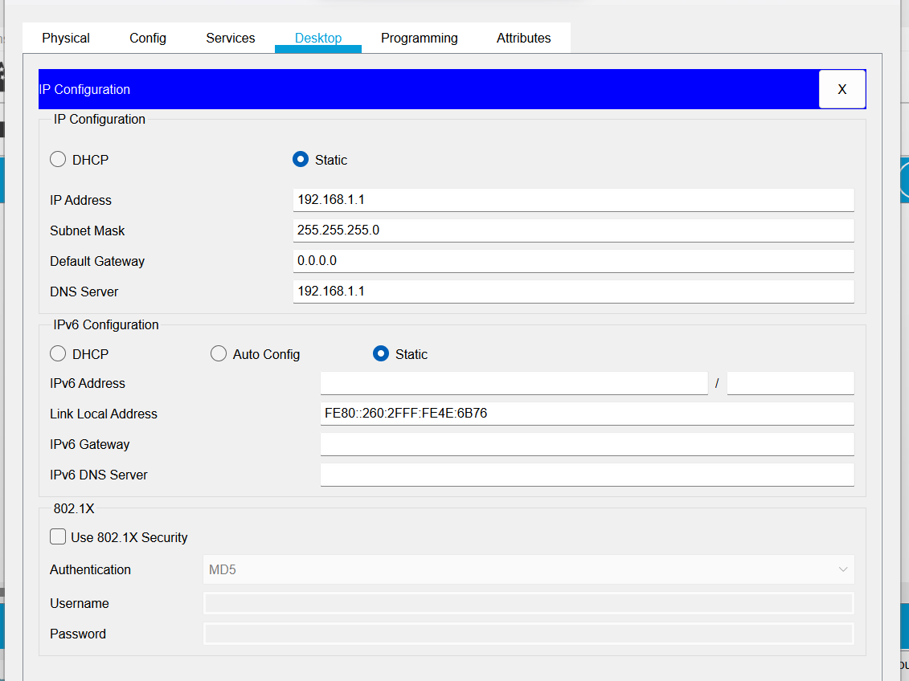

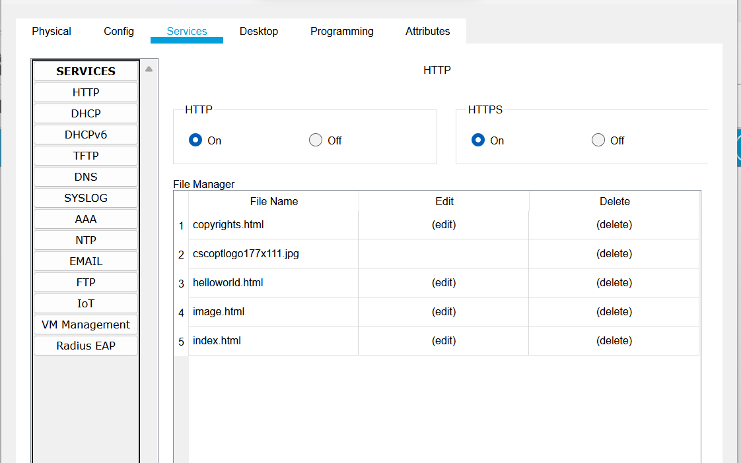

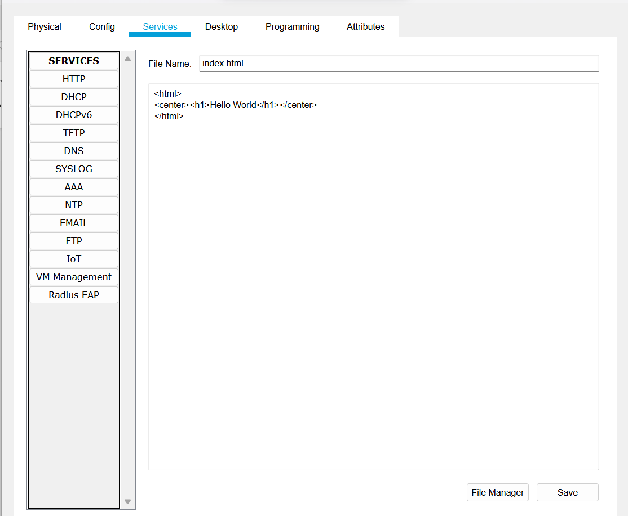

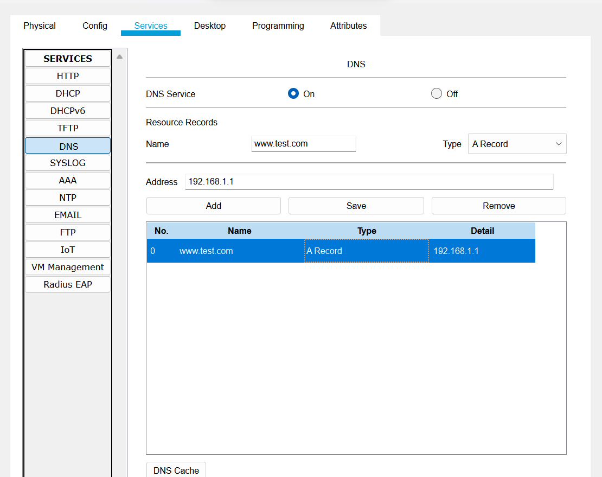

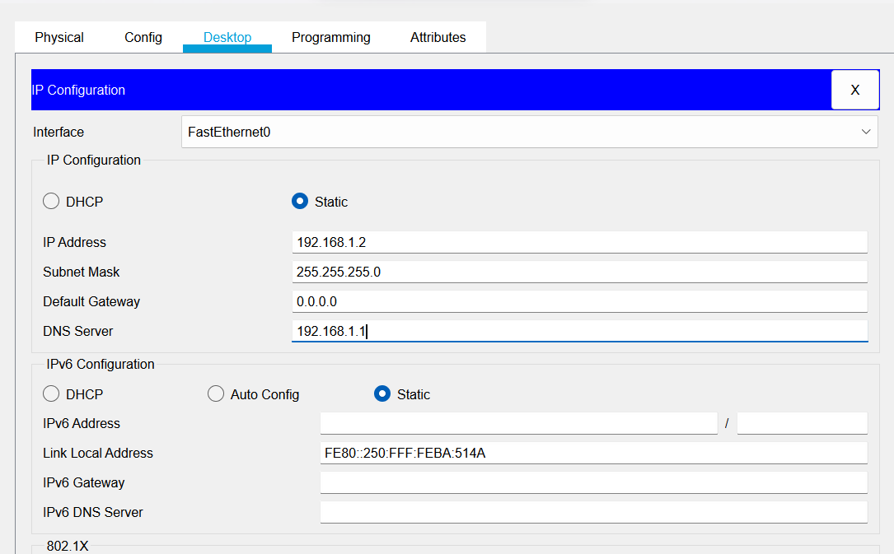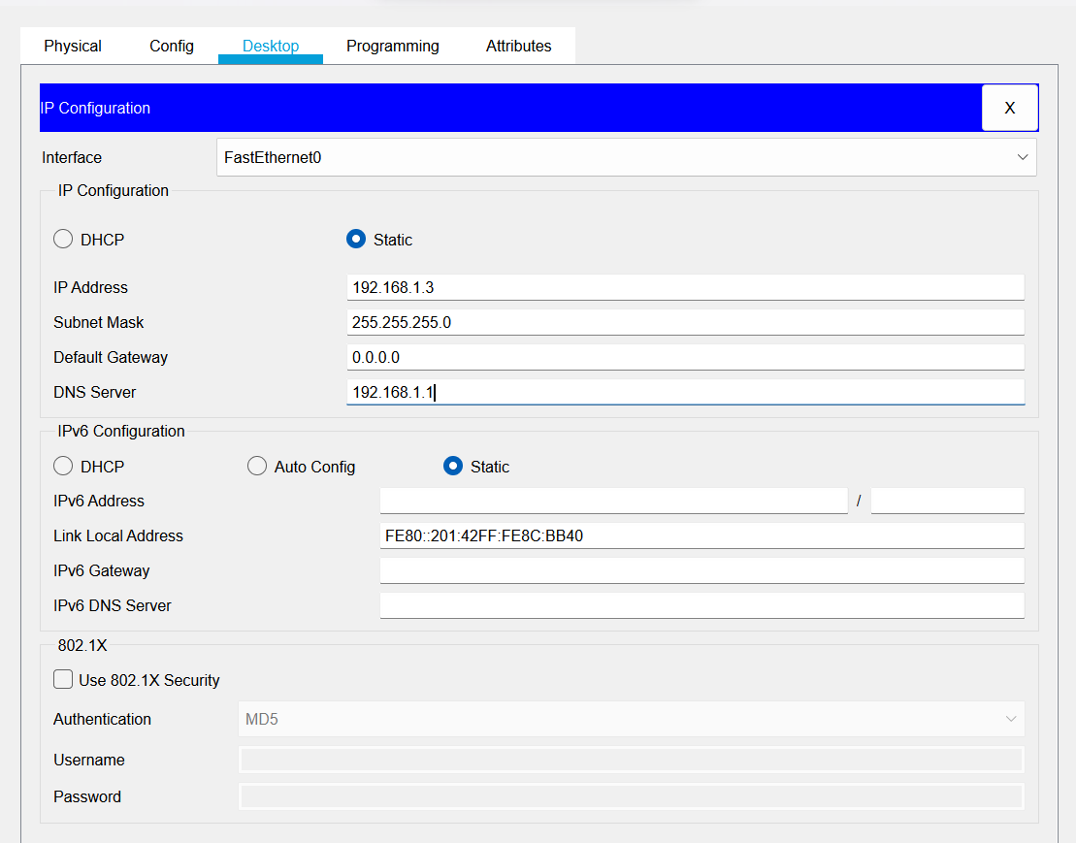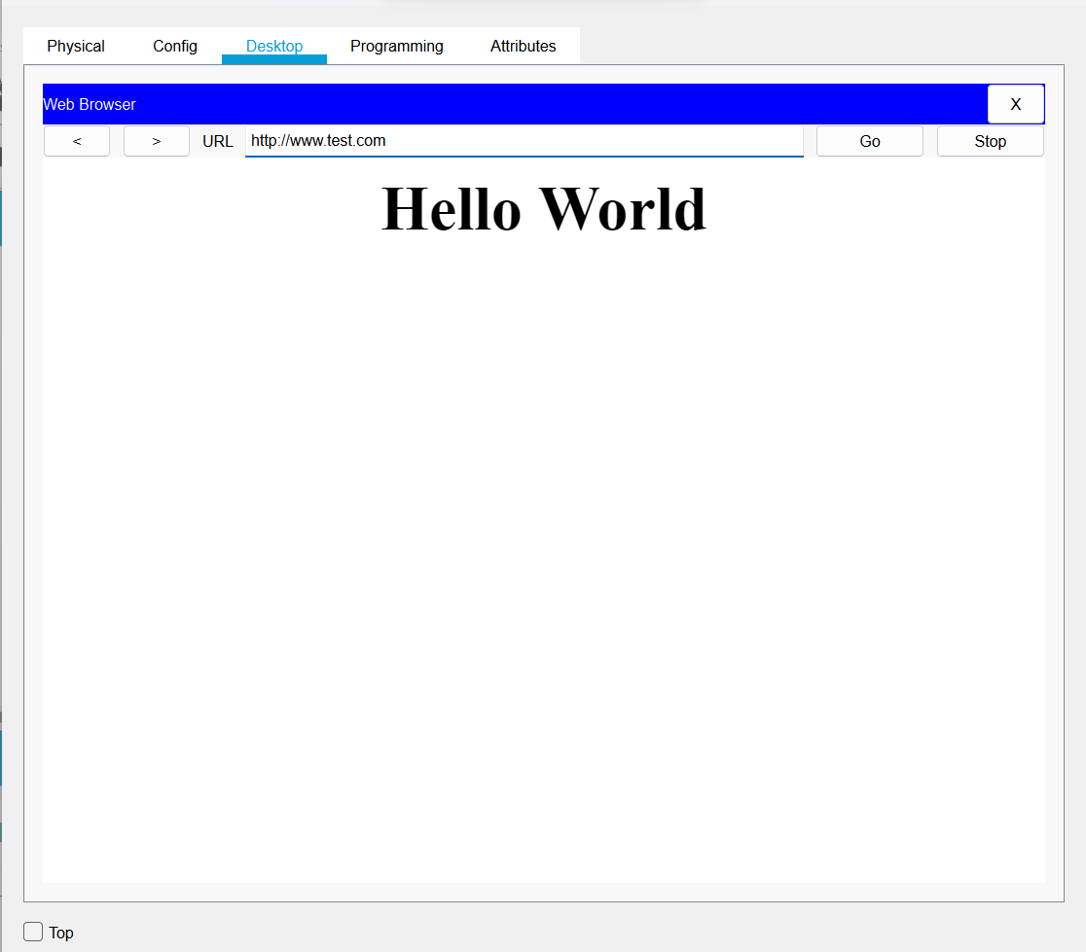

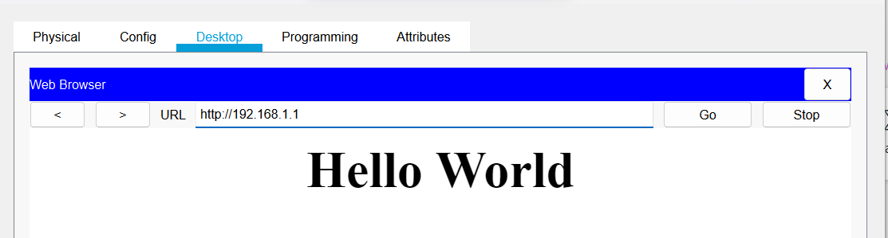

DNS& DHCP server :

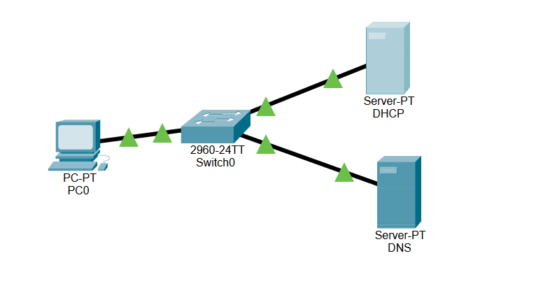

DNS:

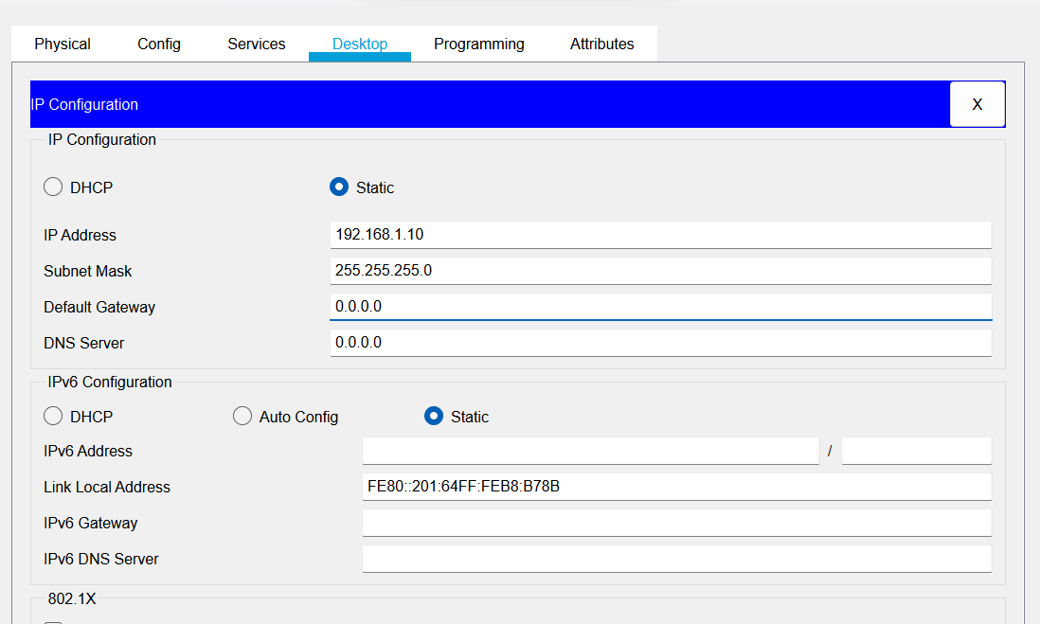

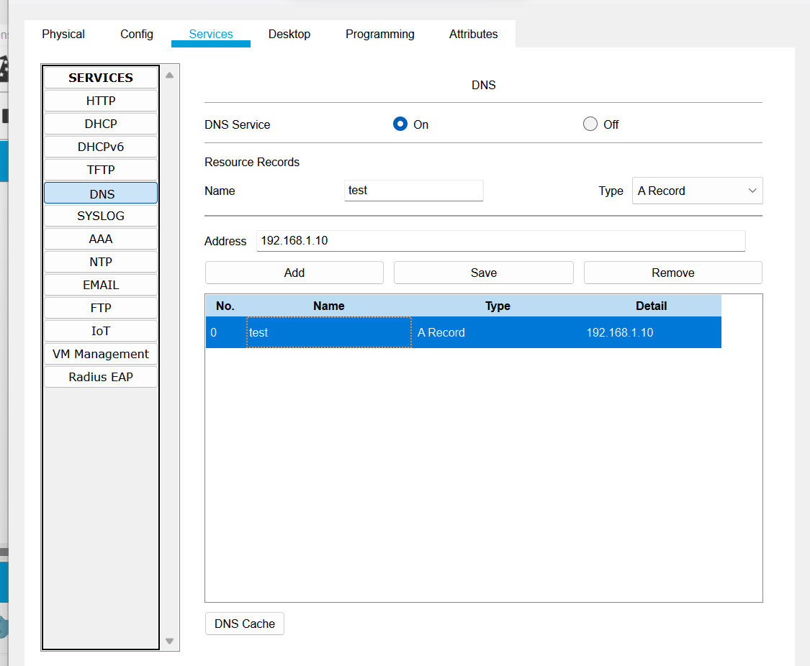

DHCP:

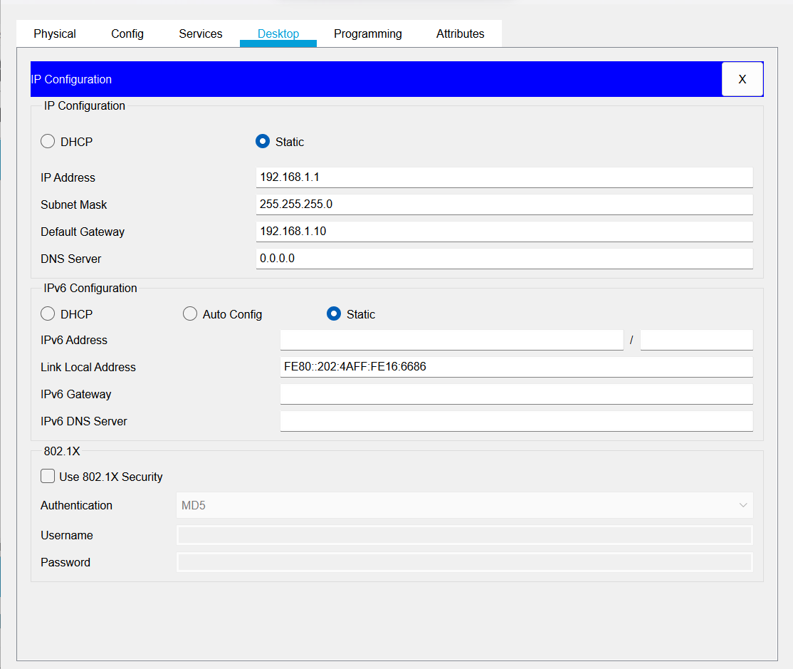

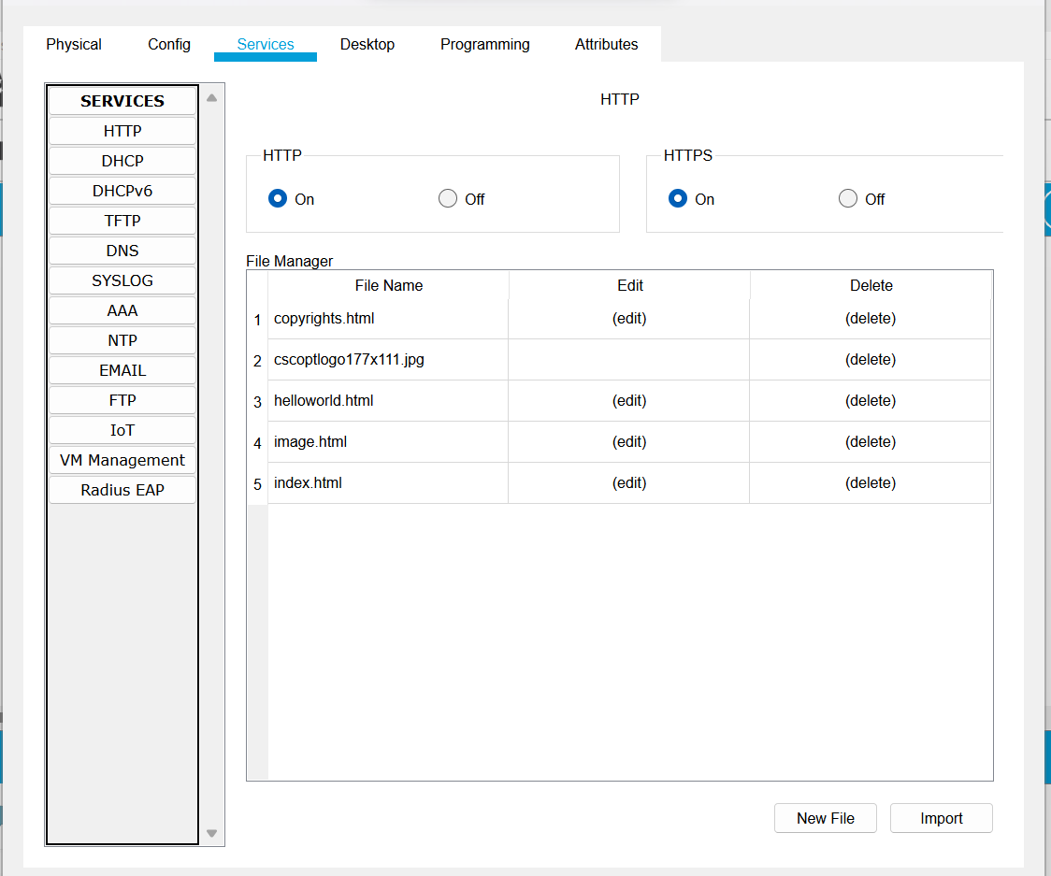

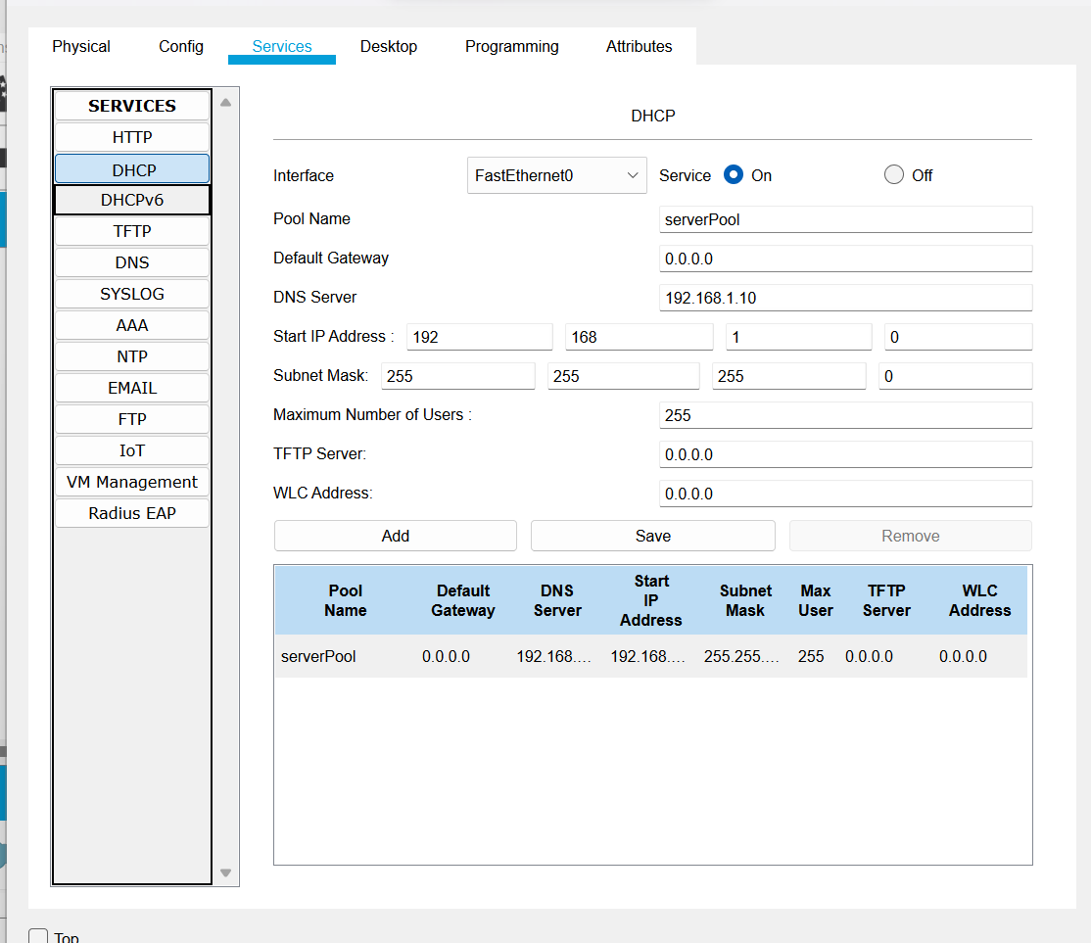

PC:

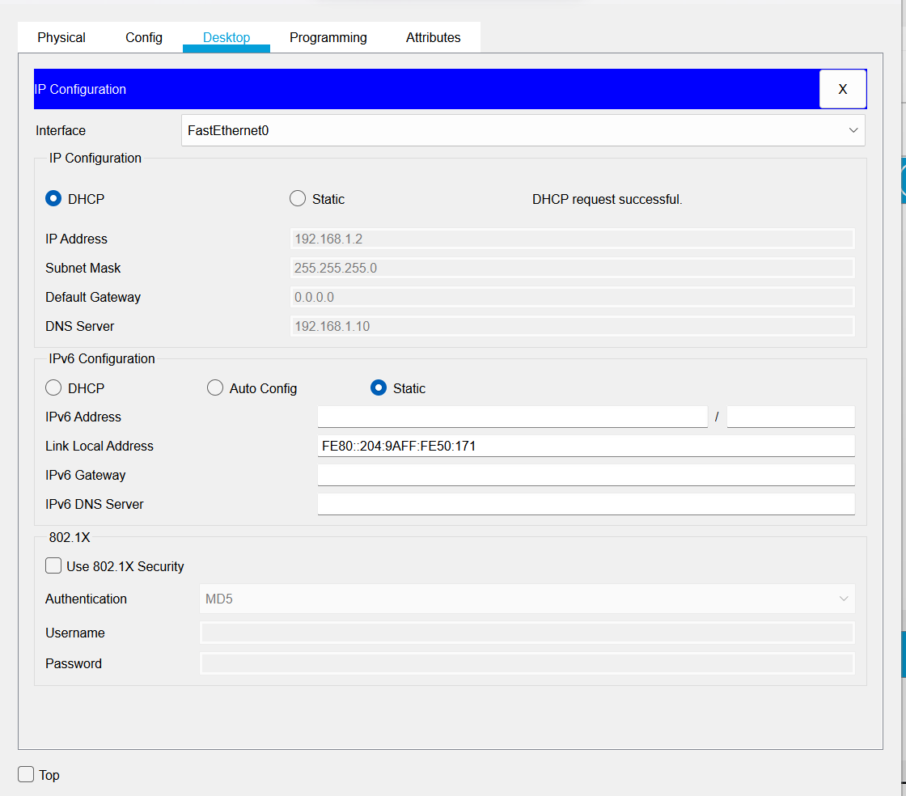

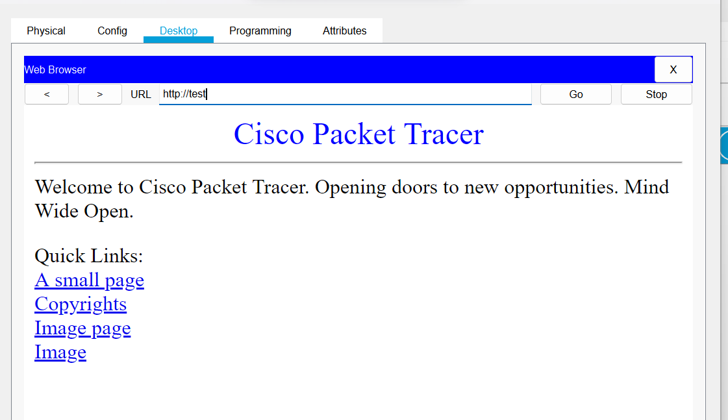

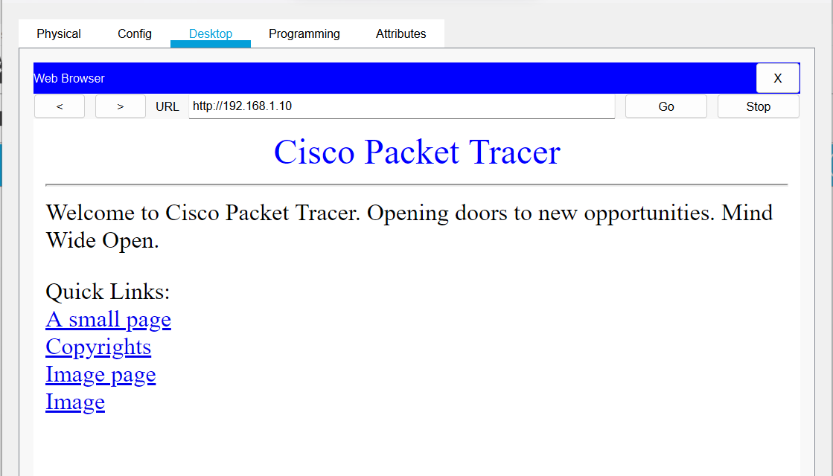

Router:

* Start
* Take 4 host, 2 switch and a router for network connection between them
* Connect them using connection wire
* Give each host IP address of class c and subnet them & default gateway
* Click router>Interface>GigabitEthernet 0/0 and set IP which was default gateway
* Click GigabitEthernet 0/1 and set IP which was default gateway
* Pass the message packet from one end device to other and from end device to router
* Perform ping test
* End

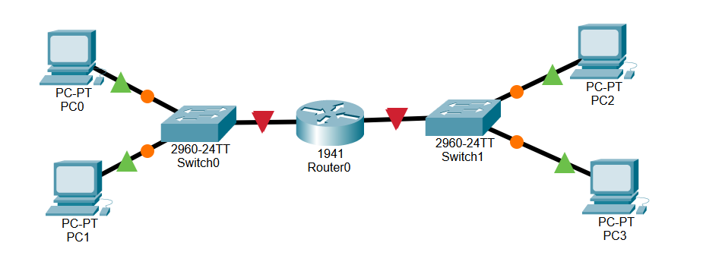

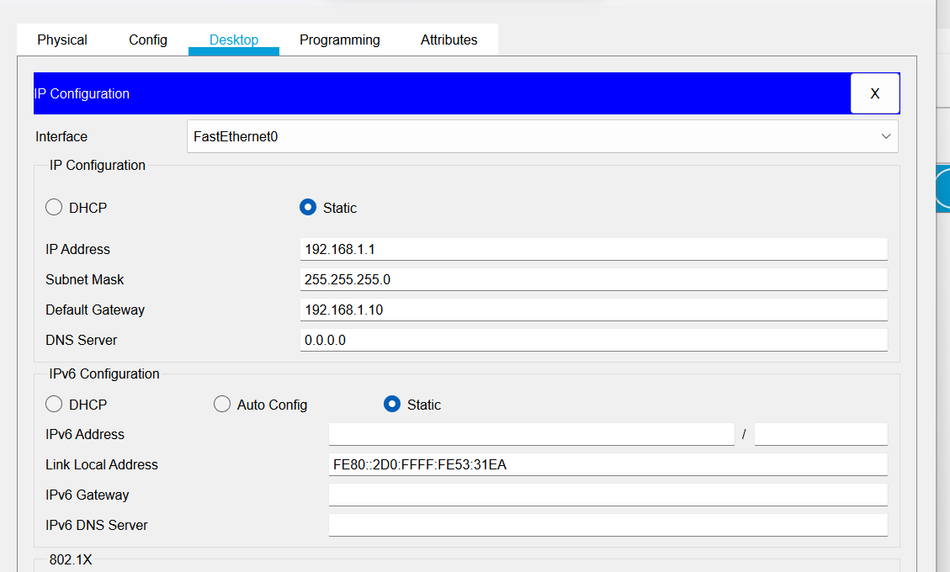

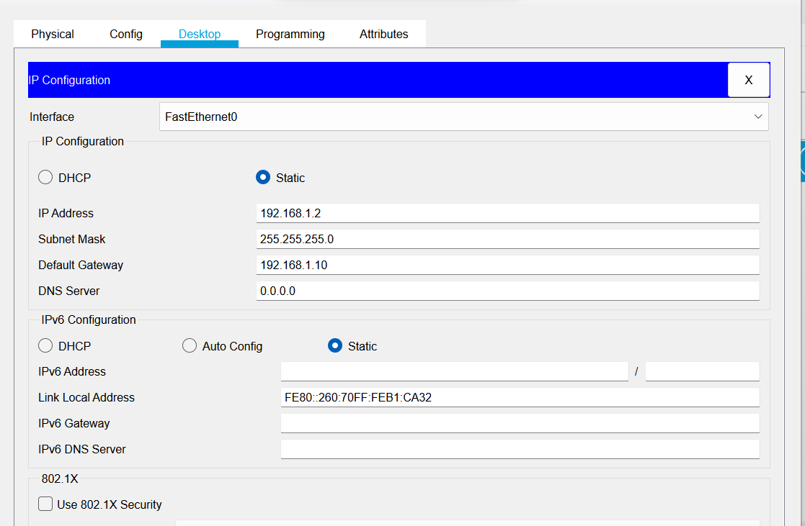

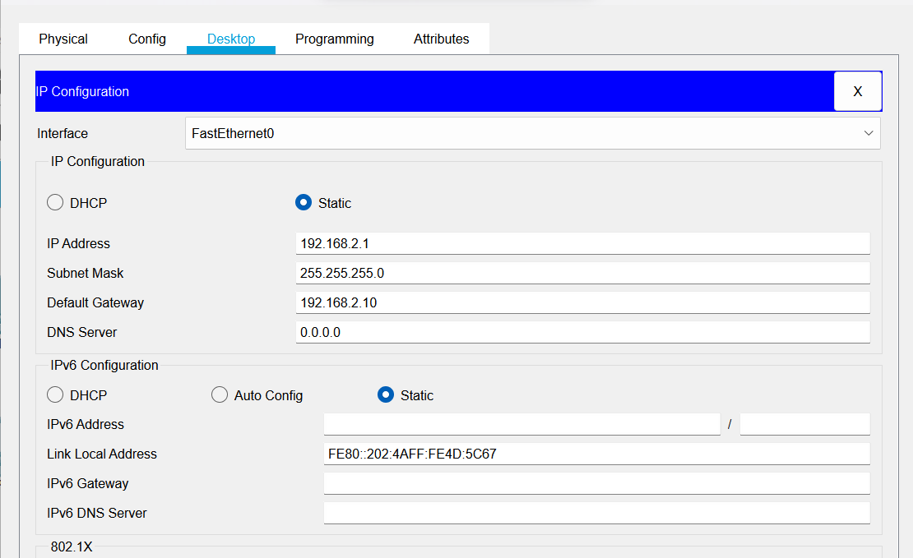

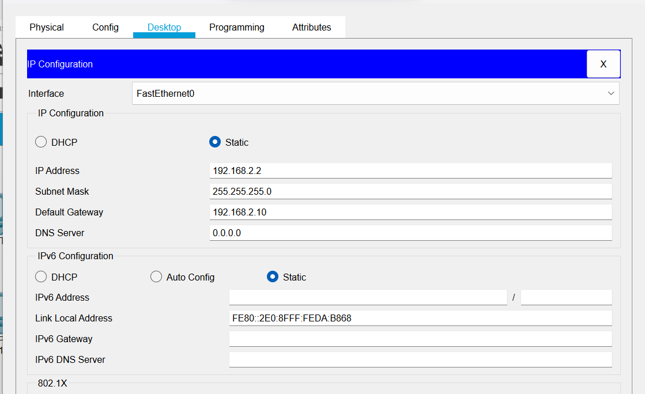

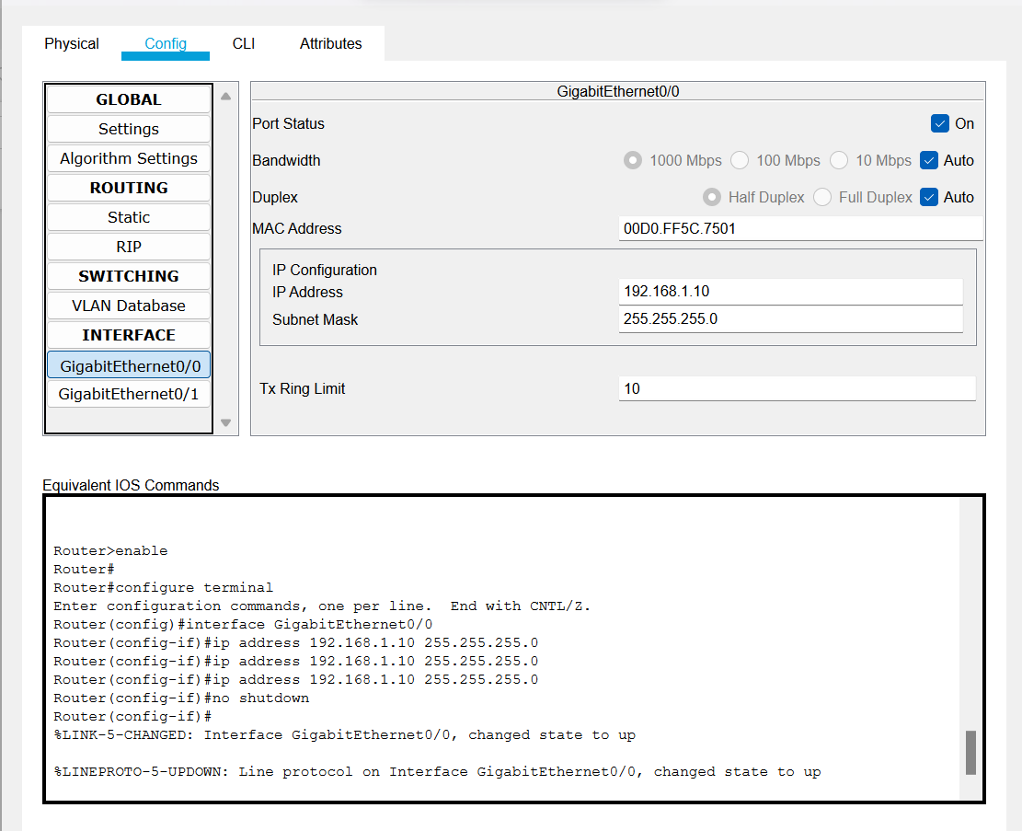

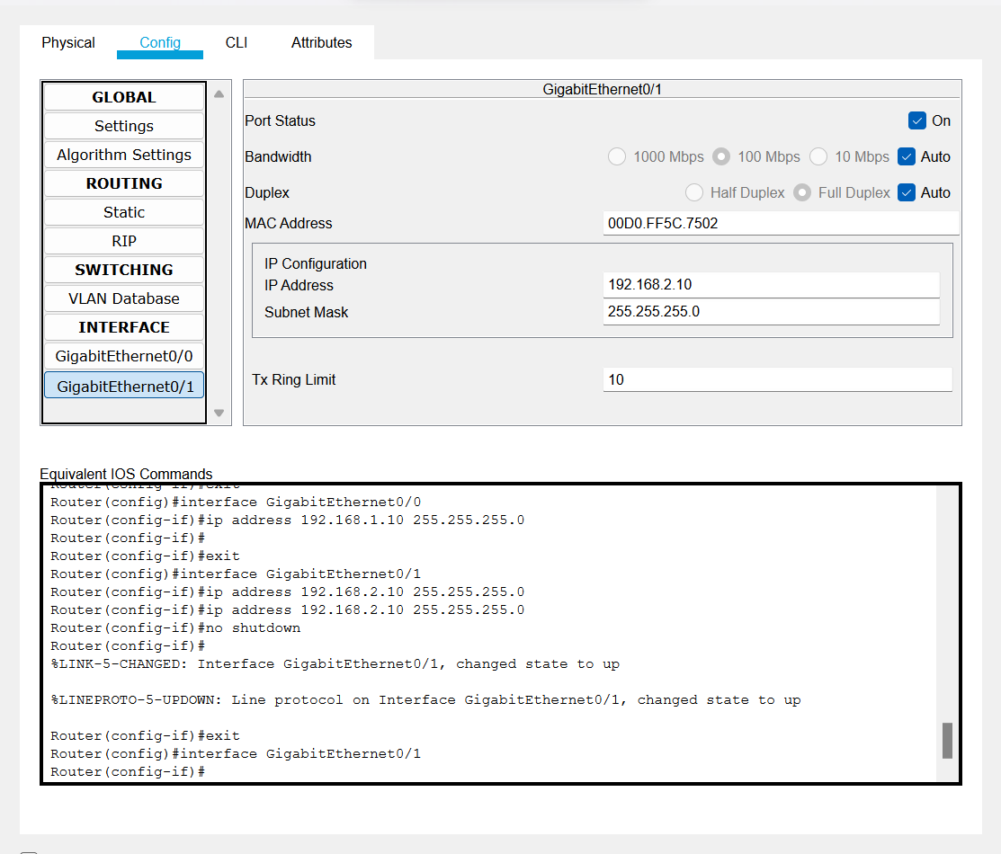

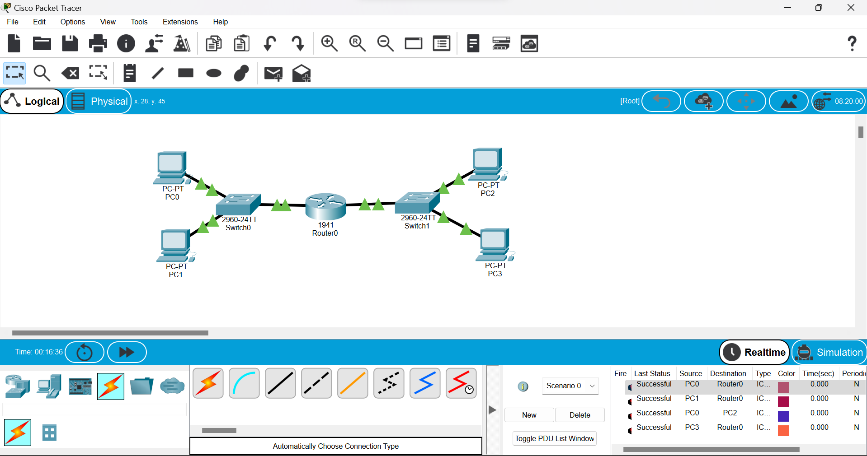

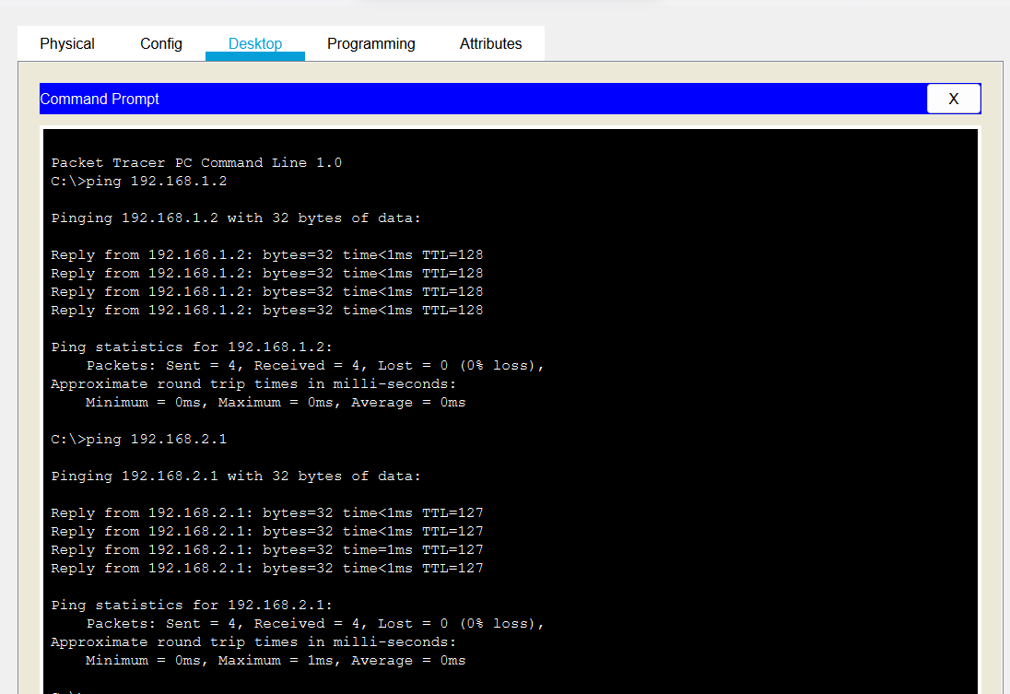

Wireless Connection:

